EARLY-GROWTH PARAMETERS ASSOCIATED WITH
TOLERANCE OF LOW-PHOSPHORUS FERTILITY IN ACID SOIL
OF FIVE NITROGEN-FIXING TREE SPECIES

A THESIS SUBMITTED TO THE GRADUATE DIVISION
OF THE UNIVERSITY OF HAWAII IN PARTIAL FULFILLMENT OF THE
REQUIREMENTS FOR THE DEGREE OF

MASTER OF SCIENCE
IN
AGRONOMY AND SOIL SCIENCES
MAY 1995

BY
Véronique Theresa Lambert

Thesis Committee:
Harold H. Keyser, Chairperson
James H. Fownes
Paul W. Singleton
Russell S. Yost

We certify that we have read this thesis and that, in our opinion, it is satisfactory in scope and quality as a thesis for the degree of Master of Science in Agronomy.
ACKNOWLEDGEMENTS

Thank you firstly to the U.S. government and to the University of Hawaii for making this thesis possible by supporting my studies and my research at NifTAL Center.
I also thank all NifTAL staff for their tremendous support, often beyond the call of duty. I am particularly indebted to Geoff Haines, Kevin Keane, Kathy MacGlashan, and Tricia Scott. Fellow students Surya Tewari and Bruce Linquist provided invaluable advice, labor, and companionship. The Nitrogen Fixing Tree Association helped get me started with seed material and technical advice.
Finally, I extend my gratitude to my advisor, Harold Keyser, who provided good-natured assistance at all stages of my thesis work.
ABSTRACT

Phosphorus is a primary constraint to agroforestry systems on acid soils of the humid tropics. Strategies of low-P tolerance were evaluated for nitrogen-fixing tree species with potential for use in such systems. Trees were grown at different P levels in an ultisol with low P fertility. Acacia auriculiformis (A.a.) and Acacia mangium were tolerant of low P. Fast growth in field-planted A.a. at low P was associated with low internal P and N concentrations and with greater BNF efficiency per unit of nodule and per unit of plant P. Growth of Gliricidia sepium, Leucaena diversifolia, and Sesbania grandiflora was greatly restricted at low P. These species had higher leaf P and N concentrations and greater biomass fractions in stems and roots. Roots of these species had less surface area per unit dry weight, and were present in larger fractions in the top soil layer.
TABLE OF CONTENTS

Acknowledgements ............................................ 3
Abstract ................................................. 4
List of Tables ........................................... 6
List of Figures .......................................... 8
Chapter 1. Thesis Introduction .......................... 9
Chapter 2. Above and below-ground growth parameters
associated with varying degrees of low-P tolerance among
six nitrogen-fixing tree species grown in acid soil ...... 13

Chapter 3. Early growth response to phosphorus and
associated differences in root parameters of four
field-planted nitrogen-fixing tree species ............... 43

Chapter 4. Utilization efficiency of P, N, leaves,
roots, and nodules in four nitrogen-fixing tree species
in response to P in an acid soil ......................... 68

Chapter 5. Thesis Conclusion ............................ 91
Appendix A. Layout of field experiment .................. 95
Appendix B. Seedling dry weight at the time of
Transplanting ............................................ 96

Literature Cited ......................................... 97
LIST OF TABLES
Table Page
2.1 Response of shoot, root, and nodule dry weight
and of nodule number to P in pot-grown trees ............. 36

2.2 Biomass partitioning to shoots, roots, and
nodules in pot-grown trees in response to P .............. 37

2.3 Specific absorption efficiency and rate of root
infection by vesicular-arbuscular mycorrhizae of
pot-grown trees in response to P ......................... 38

2.4 Whole-plant P and N accumulation in response to
P in pot-grown trees ..................................... 39

2.5 Internal P concentration of shoots, roots, and
nodules, and P utilization efficiency of pot-
grown trees in response to P ............................. 40

2.6 N₂-fixed, % of plant N derived from atmospheric N,
specific nodule activity, and P efficiency of N₂-
fixation of pot-grown trees in response to P ............. 41

2.7 Internal N concentration of shoots, roots, and
nodules, and N utilization efficiency in pot-
grown trees in response to P ............................. 42

3.1 Dry weight partitioning in 4- and 8-month old
field-grown trees in response to P ....................... 61

3.2 Plant component dry weights of 4- and 8-month old
field-grown trees in response to P ....................... 62

3.3 Soil P and pH before and after fertilization
of the field experiment .................................. 63

3.4 Component dry weight ratios in 4- and 8-month old
field-grown trees in response to P ....................... 64

3.5 Root radius and root length density of 4- and
8-month old field-grown trees in response to P ........... 65

3.6 Root surface area parameters in 4- and 8-month
old field-grown trees in response to P ................... 66

3.7 Root infection by vesicular-arbuscular
mycorrhizae in 4- and 8-month old field-grown
trees in response to P ................................... 67

4.1 Whole-plant P and N use efficiency in 4- and
8-month old field-grown trees in response to P ........... 82
LIST OF TABLES (continued)

Table Page

4.2 Phosphorus concentration of component tissue of
4- and 8-month old field-grown trees in response
to P ..................................................... 83

4.3 Whole-plant P and N accumulation in 4- and 8-month
old field-grown trees in response to P ................... 84

4.4 Nitrogen concentration of component tissue of
4- and 8-month old field-grown trees in response
to P ..................................................... 85

4.5 N₂-fixed, biological nitrogen fixation P efficiency,
and specific nodule activity in 4- and 8-month old
field-grown trees in response to P ....................... 86

4.6 Specific leaf area and net assimilation rate of
4- and 8-month old field-grown trees in response
to P ..................................................... 87

4.7 Leaf area and leaf area ratio of 4- and 8-month old
field-grown trees in response to P ....................... 88

4.8 Relative growth rate of field- grown trees at 0-4
and 4-8 months in response to P .......................... 89

4.9 Phosphorus uptake efficiency of 4- and 8-month
old field-grown trees in response to P ................... 90
LIST OF FIGURES

Figure Page

2.1 Whole-plant dry weight of pot-grown trees in
response to P ............................................ 34

2.2 Shoot and root growth of Sesbania grandiflora
in response to P, with and without inoculation ........... 35

3.1 Whole-plant dry weight of inoculated and
uninoculated field-grown trees, 4 and 8 months
old, in response to P .................................... 60
CHAPTER 1. Thesis Introduction

Importance of Phosphorus in Agroforestry Systems in the Humid Tropics
Agroforestry, the managed combination of tree production with that of crops or livestock, can be a viable land-use system on marginal soils in the humid tropics. Agroforestry systems fulfill various needs, including those for food, fuel-wood, or livestock feed, in areas with erodible soils and low soil fertility. Phosphorus has been identified as the nutrient of most concern to the success of agroforestry systems in tropical regions (Palm et al., 1991; Shepherd, 1991). This thesis addresses the problem of P constraints to agroforestry systems in the humid tropics by investigating strategies of low-P tolerance in nitrogen-fixing tree (NFT) species adapted to that environment.
One reason for the concern with P is the prevalence of soils with high levels of P-fixation in the tropics. Soils with high P-fixing capacities are particularly widespread in the humid tropics, accounting for 38% of the land in this region (Sanchez and Logan, 1992).
Focus on P limitation in agroforestry also results from the realization that P is necessarily exported out of agricultural systems with harvests, especially of P-rich components such as grain. Phosphorus inputs are required to sustain any system from which there are P losses. In regions where economic and infrastructural constraints forbid copious use of chemical fertilizers, employing species that are inherently well-adapted to low P fertility reduces the need for external inputs.
A third reason for concern with P in agroforestry systems is the importance of this nutrient for biological nitrogen fixation (BNF) (Cassman et al., 1980 and 1981; Gates, 1974; Israel, 1987). Nitrogen, as the most limiting nutrient in agriculture (Singer and Munns, 1987), is often a major constraint to tree and crop growth. The use of NFTs in agroforestry systems can alleviate the problem of N deficiency in soil for both trees and companion crops or livestock (Dommergues, 1987; Siaw et al., 1991; Szott et al., 1991). To realize the benefits of BNF to the system, P supply should be sufficient to maintain the BNF symbiosis.
In this thesis, low-P tolerance of NFTs is investigated in acid soil since high P-fixation is commonly associated with acid soils (Sanchez and Uehara, 1980). Soil acidity, like P infertility, is unlikely to be amended in many agroforestry systems in the humid tropics due to economic and infrastructural constraints. Therefore, acid-tolerance is often implicit in the low-P tolerance of agroforestry species. The soil used in this research, an ultisol, exhibited very low levels of plant-available P, as well as low pH, but had low Al saturation. Therefore, this research is most relevant to the smaller, yet substantial, proportion (24%) of acid soils in the humid tropics that is not constrained by Al toxicity (Sanchez and Logan, 1992). Because soil acidity in this research was unamended, species with some degree of reputed acid tolerance were selected to be tested for their low-P tolerance.
Environmental Adaptation and Uses of NFT Species Selected for Experimentation
Fast-growing, NFT species were selected first for their current or potential importance to agroforestry on marginal soils in the tropics. Other selection criteria were adaptation to lowland, humid tropics, tolerance of soil acidity, identification of effective rhizobia, and availability of seed. The six species selected are described as follows.
Acacia angustissima is found in North and Central America. A short, shrubby tree which resprouts after cutting, it has good potential for use in hedgerows, as nurse trees, and for rehabilitating degraded land (Benge, 1990).
Acacia auriculiformis and Acacia mangium are exceptionally hardy species, particularly A. auriculiformis which withstands many environmental extremes. Both species tolerate soil infertility and acidity (to pH 3 and 4 respectively). They occur naturally in humid tropical areas of Australia, Papua New Guinea, and Indonesia with annual rainfall of 1000-3000 mm and altitudes below 100 m (Turnbull, 1987a, 1987b). These species are suitable for fuelwood, wood, shade, and rehabilitation of degraded sites.
Gliricidia sepium is a widely used species that originated in Mexico and Central America. It is used to provide many products and services including shade, support, living fences, fuelwood, animal feed, and green manure. This species has broad adaptability within the humid tropics and some provenances can grow well on acid and infertile soils (Chadhokar, 1982).
Leucaena diversifolia, a native of Mexico and Central America, prefers fertile soils and cooler and wetter sites at higher elevations (700 to 2500 m). However, it does colonize lower-elevation (0-500 m) sites with higher temperatures, lower rainfall (650 mm), and low fertility, and can tolerate moderate acidity. The primary uses of this species are fuelwood, posts, pulpwood, shade, and reforestation (Bray and Sorennson, 1992).
Sesbania grandiflora, native to Southeast Asia, is adapted to the lowland (0-500 m) humid (1000-2000 mm rainfall) tropics and does not tolerate cool temperatures. It is used for fodder, green manure, pulp, shade, and human food. Some Sesbanias grow well on acid soils (NFTA, 1990).
Thesis Objectives
This research was undertaken to address a need, articulated by Shepherd (1991) in a review paper, for information on the performance of NFT species on low-P sites. Species adapted to low-P conditions are required for low-input agroforestry systems, and information on their growth characteristics with low P fertility is necessary for effective species selection and management. The success of agroforestry systems depends on correctly matching NFT species with the needs of the system. For example, as Shepherd (1991) points out, a species adapted to low-P by virtue of slow growth and/or low leaf P concentration would not be effective in supplying P to companion crops.
The objectives of this thesis were, first, to determine the relative low-P tolerance of acid-tolerant NFT species; and, then to identify growth parameters associated with tolerance of and sensitivity to low P availability. Knowledge generated by this research is intended to facilitate effective selection and management of NFT species for successful establishment in P-limited systems in the humid tropics. The thesis focuses on early-growth performance since good tree establishment is critical to successful agroforestry. Trees require a longer time for establishment than most crops and often must compete with aggressive weeds.
Performance of the selected NFT species in low-P soil was assessed in the light of three strategies for plant survival of low fertility, outlined by Mulligan and Patrick (1985): 1) slow growth, 2) efficient nutrient acquisition, and 3) efficient nutrient utilization. Performance of the species was initially assessed in a pot experiment, reported in Chapter Two. Species that displayed different degrees of P responsiveness in the pot experiment were selected for further study in the field. In Chapters Three and Four, indicators of the strategies employed to tolerate low P fertility are assessed for the different species. Chapter Three assesses indicators of the species’ growth rates and efficiencies of nutrient acquisition, and investigates the association of these parameters with low-P tolerance. Chapter Four looks at the association between low-P tolerance and efficiency of P and tissue utilization.
CHAPTER 2. Above and below-ground growth parameters associated with varying degrees of low-P tolerance among six nitrogen-fixing tree species grown in an acid soil.

ABSTRACT
The objective of this study was to generate information about elements of low-P survival strategies of nitrogen-fixing tree (NFT) species with potential for use in acid soil systems. In a greenhouse pot experiment, six NFT species, Acacia angustissima (A. ang.), Acacia auriculiformis (A.a.), Acacia mangium (A.m.), Gliricidia sepium (G.s.), Leucaena diversifolia (L.d.), and Sesbania grandiflora (S.g.), were grown at 5 levels of applied P (0, 25, 75, 200, and 400 g P kg⁻¹ soil) in an ultisol with pH 4.5. Acacia angustissima grew poorly at all P levels. Acacia auriculiformis and A.m. maintained moderate growth across P levels and were termed non-responsive to P. Leucaena diversifolia and S.g. increased biomass production at high P. They were termed most P-responsive, with biomass at 400 P being 2.3 times that of the 0 P control. Gliricidia sepium was the least P-responsive (P<0.17), with 1.3 times the biomass at 400 P as at 0 P. Acacia auriculiformis’ and A.m.’s lack of P-response was associated with slower growth, greater P uptake efficiency of roots (specific absorption efficiency (SAE), g P in plant g⁻¹ roots), higher internal P utilization efficiency (PUE, g dry weight g⁻¹ P in plant), greater efficiency of biological nitrogen fixation (BNF) per unit of P assimilated (BNF P efficiency (BNFPE), g N₂ fixed g⁻¹ P in plant), and higher specific nodule activity (SnA, g N₂ fixed g⁻¹ nodule). Increased P uptake by A.a. and A.m. at higher P levels resulted in elevated P concentrations internally. The higher rate of vesicular arbuscular mycorrhizae (VAM) root infection in A.a. suggests that VAM symbioses may have imparted greater low-P tolerance to the Acacia species. Biomass production was highest and shoot and root tissue P concentrations were lowest in G.s. than in any other species at all P levels. Gliricidia sepium had the highest PUE, BNFPE, and SnA. However, the degree of growth increase with added P was less in G.s. than in the other responsive species. Its P response may have been limited by the low SAE of its roots. The greater restriction of L.d.’s and S.g.’s growth by P infertility was associated with a relatively high internal P demand for growth and BNF.

INTRODUCTION
The prevalence of P-deficient acid soils in the tropics (Sanchez and Logan, 1992) necessitates the utilization of nitrogen-fixing tree (NFT) species tolerant of such conditions in low-input agroforestry systems. Furthermore, the ubiquity of N limitations to agriculture (Singer and Munns, 1987) also calls for the tolerance of the biological nitrogen fixation (BNF) symbiosis to P infertility. Due to the broad diversity of agroforestry systems, information on the strategies with which NFT species cope with P deficiency is needed to improve species selection and management for these systems. Previous research has identified three primary elements of plant strategies for tolerating low fertility by maintaining low nutrient demand: 1) lower growth rates (Aerts, 1990; Blair and Wilson, 1990; Mulligan and Sands, 1988; Mulligan and Patrick, 1985), 2) efficient nutrient acquisition (Chapin, 1980; Paynter, 1993), and 3) efficient internal economies via increased efficiency in nutrient redistribution and in metabolic utilization (Crawford et al., 1991; Haynes et al., 1991; Israel and Rufty, 1988; Mulligan and Sands, 1988; Sanginga, 1994).
This paper reports on a preliminary investigation of the strategies of six NFT species for coping with P infertility in acid soils. There are two objectives. The first is to assess the low-P tolerance of six NFT species, Acacia angustissima, Acacia auriculiformis, Acacia mangium, Gliricidia sepium, Leucaena diversifolia, and Sesbania grandiflora. The second objective is to identify differences in growth parameters among the species that may account for differential tolerance to low P availability.
A significant component of low-P tolerance in plants is low demand for external P (Barber, 1984; Chapin, 1980) which can result from slow growth. For this study, it was hypothesized that species with greater low-P tolerance would have inherently slower growth rates at all P levels. Others (Aerts, 1990; Chapin, 1980; Mulligan and Sands, 1988) have shown that genotypes adapted to low fertility had slow growth and did not respond to improved fertility. Plants adapted to high fertility likewise will often display reduced growth under a nutrient stress, but possess the potential to increase growth should fertility improve (Aerts, 1990; Asher and Loneragan, 1967; Mulligan and Sands, 1988; Sanginga, 1992).
In addition to slow growth, species tolerant of low P fertility may employ other factors to maintain low soil P demand. One key element of a strategy of low P demand is a high PUE. Crawford et al. (1991) observed lower P concentrations in pine trees when unfertilized. They also found comparatively lower P concentrations in pine families that were more tolerant of soil infertility. However, some species adapted to high fertility conditions that have fast growth rates may actually produce biomass at a lower nutrient cost (Chapin, 1980). Such was the case for fast-growing deciduous grass from fertile sites studied by Aerts (1990). Compared to slow-growing evergreen shrubs adapted to poor fertility, the deciduous species produced more biomass per unit of P assimilated. Mulligan and Sands (1988) also found that under nutrient-limiting conditions, Eucalyptus species adapted to low-fertility sites had higher tissue P concentrations than species from more-fertile sites.
Demand for fertilizer-P may also be reduced through effective symbiosis with mycorrhizae (Mosse, 1981). For a given fertilizer application, higher rates of VAM infection could result in greater P uptake. Another factor in the strategy to maintain low demand for fertilizer-P can be a higher root efficiency for P uptake at low levels of soil P (Paynter, 1993). However, as demonstrated by Blair and Wilson (1990) in a comparison of white clover accessions, adaptation to low P fertility is not necessarily related to greater efficiency in P uptake.
For the current study, it was hypothesized that those species displaying greater tolerance of low-P fertility would have higher PUE, higher VAM infection rates, and greater SAE.
The P efficiency of the BNF symbiosis is crucial too in systems that are limited by N as well as by P. Phosphorus serves a critical role in BNF (Cassman et al., 1981), and, in agroforestry systems on low-fertility sites, NFTs are commonly expected to be at least self-sufficient in N. Some authors have concluded that the restriction of nodulation and BNF at low P occurs because host plant growth is first restricted (Robson, 1983, Reddell et al., 1988). But others have observed, rather, that a P deficiency can restrict nodulation and BNF to a greater extent than plant growth (Cassman et al., 1980, 1981; Israel, 1987; Pongsakul and Jensen, 1991). A P deficiency can also inhibit nodule function. Gates (1974) found that nodules fixed less N₂ when P supply was low. In light of the importance of BNF in the N nutrition of NFTs growing in infertile soil, it was hypothesized that tolerance of P infertility would require a BNF symbiosis that is also low-P tolerant.
The effect of P on the BNF symbiosis itself was assessed through indirect analyses by: 1) calculating P efficiency of BNF (BNFPE), i.e., the amount of N fixed per unit of absorbed P; and 2) calculating specific nodule activity (SnA), i.e., the amount of N fixed per unit of nodule dry weight.
The degree to which plant growth is affected by reduced fertility varies by genotype and is associated with such factors as biomass and nutrient partitioning. Phosphorus deficiency often results in relatively less biomass and P allocation to shoots and more to roots (Fredeen et al., 1989; Israel and Rufty, 1988; Mulligan and Sands, 1988; Pongsakul and Jensen, 1991). In the case of N₂-fixing plants, partitioning to nodules also plays a significant role in plant response to P. Cassman (1980) observed that P-deficient soybeans allocated biomass preferentially to roots, to the detriment of nodule development. Restricted nodule development can inhibit growth of plants that are dependent on BNF as a N source. In the current study, the expectation was that species adapted to low-P conditions would exhibit smaller increases in biomass partitioning to roots at the expense of shoots and nodules.
In this experiment, P-responsiveness was first determined from total biomass response to P availability by six NFT species. Then above and below-ground growth parameters associated with the species’ P responsiveness were assessed as elements of possible strategies for coping with low P. Parameters assessed were biomass partitioning, P uptake, P partitioning, N₂ fixation, and efficiency of the following: P and N use, P uptake, nodule function, and BNF.

MATERIALS AND METHODS
Species Selection and Seed Source
Six fast-growing, multi-purpose, NFT species used in tropical agroforestry systems were included in this experiment. Species reputed in the literature to have some degree of acid tolerance (see Thesis Introduction) were selected to avoid confounding the effect of P with that of soil acidity per se. All of the species are adapted to, or have been reported to grow in, lower elevation sites of the humid tropics (see Thesis Introduction). One little-known species, Acacia angustissima, was included in this study. Despite the paucity of information in the literature on this species, the Nitrogen Fixing Tree Association (NFTA) made a strong case for its potential as a valuable acid soil species (personal communication).
The following seeds were obtained from NFTA, (NFTA accession number): Acacia angustissima (777) from Waimanalo, Hawaii; Acacia auriculiformis (894) from Singapore; Acacia mangium (276b) from Mossman, Australia; Gliricidia sepium (604) from Kunia, Hawaii; Leucaena diversifolia (K156) from Waimanalo, Hawaii. Sesbania grandiflora seeds were obtained from the Pan American Development Foundation’s agroforestry project in Haiti (seed lot #477).
Plant Growth Conditions and Experimental Design
The pot experiment was started on August 23, 1992 in a greenhouse at Hamakuapoko, Maui, Hawaii. Three-liter black plastic pots were lined with polyethylene bags and filled with 2 kg soil (dry weight basis) which had been passed through a 5 mm sieve. The soil, an ultisol, was the Haiku clay (clayey, oxidic ischyperthermic Typic Palehumult), with a pH of 4.5 (1:1, H₂O:soil). KCL-exchangeable Al, at 1.2 cmol_{c} kg⁻¹ soil, accounted for 54% of the soil’s cation exchange capacity (K+Ca+Mg+Na+Al). Double acid (DA) extractable soil P was 0.81 μg g⁻¹ soil. Soil P was measured using a modification of Nelson et al., (1953), i.e., 0.05 M HCL + 0.05 M H₂SO₄ DA extractant at a 1:10 soil:solution ratio, with 5 minutes of shaking. Average daily soil temperature in the pots was 32°C.
The soil was expected to contain indigenous populations of VAM. It was collected from a site that was vegetated with grasses, and that had previously been cultivated with pineapple, a crop known to be mycorrhizal (Mosse, 1981). Subsequent determinations of indigenous rhizobial populations in the study soil indicated that the Acacia species in this study could be infected by indigenous soil rhizobia (see Chapter 3 for materials and methods). A separate pot study conducted concurrently indicated that the growth of uninoculated NFTs in this soil, unamended with P or N, was first limited by N (data not shown).
Each of the six species was grown in soil with five P levels (0, 25, 75, 200, and 400 g P kg⁻¹ soil). Phosphorus levels were selected to determine the minimum P level required for fulfillment of acid-soil growth potential by these species. Results of a soybean P-response experiment conducted in similar soil (Singleton et al., 1985) guided the selection of P levels. Species and P treatments were arranged factorially within a randomized complete block design with three replications.
Basal nutrients supplied to all pots were (g kg⁻¹ soil): 505 K, 26 Mg, 50 Ca, 81 to 288 S, 8.81 Fe, 2.94 Zn, 2.64 Mn, 2.05 B, 0.88 Cu, 0.24 Mo, and 0.18 Co. These nutrients were supplied by additions of KH₂PO₄, K₂SO₄, MgSO₄·7H₂O, CaSO₄·2H₂O, and a liquid micronutrient mix (Hawaiian Horticultural Mix, Monterey Chemical Co.). The co-varying anion was SO₄²⁻. Nutrients were mixed with deionized water and a one-time application was made to the soil in pots three days before pregerminated seeds were transplanted. Pots were watered to field capacity (0.40 g H₂O g⁻¹ soil) with deionized water every two days.
Plant Culture
Seeds were scarified and surface-sterilized before planting. Acacia angustissima, A.a., A.m., and L.d. were soaked in concentrated H₂SO₄ for 20, 20, 15, and 15 minutes, respectively. Sesbania grandiflora seeds were scarified mechanically by nicking the seed coat, then surface sterilized with a two-minute soak in a 2.6% sodium hypochlorite solution. Seeds of G.s. did not require scarification. They were surface sterilized directly by soaking for one minute in a 2.6% sodium hypochlorite solution. Immediately after treatment, seeds were rinsed several times with sterile water and soaked overnight in the final rinse. Seeds of G.s. were soaked for two hours only. The final rinse of A.a. and A.m. was in boiling water. Seeds were then planted in autoclaved horticultural vermiculite and inoculated with rhizobia.
Inoculum for each species was a mixture of effective rhizobial strains. Strains were first grown separately in yeast extract mannitol broth (Vincent, 197O), then mixed in equal parts. Inoculum strains were: TAL 569, TAL 85O, TAL 1426, TAL 1446, and TAL 153O for A.a.; A.a. strains plus RAD 712 for A. ang.; Aust 13c, CB 3156, TAL 1388, TAL 1867, and TAL 47 for A.m.; TAL 1145, TAL 1455, TAL 1770, TAL 1806, and TAL 1884 for G.s. and L.d.; TAL 674, TAL 1113, TAL 1114, and TAL 1119 for S.g.¹. The inoculation rate was approximately 30 x 10⁷ cells per seed.
Upon emergence, seedlings were selected for uniformity, transplanted into the pots of soil, and inoculated a second time, at the rate of 10⁸ cells plant⁻¹. Seven L.d. seedlings were transplanted into each pot. For all other species eight seedlings per pot were transplanted. After seven days, the pots were thinned. To avoid differential growth limitation by pots among species, the final number of plants per pot differed by species according to anticipated growth. Acacia mangium was thinned to seven plants per pot; A. ang. and A.a. to six; L.d. to five; and G.s. and S.g. to four.
All species except S.g. were sprayed with Talstar insecticide (bifenthrin) to control whitefly and with Benlate (benomyl) to control powdery mildew at 10 weeks after transplanting. Afterwards, A.a. and A.m. suffered some phytotoxicity, and whitefly infestation of G.s. persisted.
Plant Harvest and Nutrient Analysis
Time of harvest was staggered by species, with faster-growing species harvested earlier. Sesbania grandiflora was harvested at 68
¹TAL strains are from NifTAL Center, Hawaii. Aust, CB, and RAD, strains are from R.A. Date of CSIRO, Brisbane, Australia.
days after transplanting (DAT), G.s. at 86 DAT, A.m. at 109 DAT, L.d. at 110 DAT, and A. ang. and A.a. at 111 DAT.
Shoots (cut at the cotyledonary node), roots, and nodules were separated, cleaned, oven-dried, weighed, and ground with a Cyclotech sample mill. Nodules were also counted before being dried. Ground samples of each plant component were analyzed for N by combustion in a LECO CHN autoanalyzer, and for P using Watanabe and Olsen’s (1965) method of colorimetric P determination on dry-ashed samples. For some very small nodule and root samples, colorimetric determinations of N (Dorich and Nelson, 1983) and P (Watanabe and Olsen, 1965) were made from aliquots of a common H₂SO₄-H₂O₂ wet digest (Miller and Miller, 1948). Nitrogen and P analysis was not conducted on A. ang. due to its exceptionally poor growth at all P levels.
VAM Infection Assessment
None of the plants were inoculated with VAM, but they were assessed for infection by mycorrhizae indigenous to the soil used in this study.
About 1 g of fresh roots, sampled from the entire root system of each pot, was extracted after roots were washed. These samples were stored in a formalin-acetic acid-alcohol killing and fixing solution before they were stained as described by Koske and Gemma (1989). Vesicular arbuscular mycorrhizal infection of the stained roots was quantified for A.a., L.d., and S.g. at the 0, 75, and 400 P levels. Percent infection was estimated using the gridline-intersect method (Giovannetti and Mosse, 1980).
Estimation of Biological Nitrogen Fixation
Biological nitrogen fixation in each species, at three P levels, was estimated using the difference method (Peoples et al., 1989). Uninoculated S.g. was used as the reference species to estimate the amount of soil N assimilated by all inoculated plants. On a separate greenhouse bench, uninoculated S.g. plants were grown at 0, 75, and 400 g P kg⁻¹ soil, in a randomized complete block design with three replicates. Growth conditions, plant culture, and N analysis were the same as for the inoculated plants, and they were harvested at the same time as the inoculated S.g.
The quantity of N fixed by each inoculated species was calculated at 0, 75, and 400 P as:
N fixed = N_{I} - Ut_{I}
where N_{I} is total N in shoots, roots, and nodules of the inoculated plants; U is the daily rate of N uptake by uninoculated S.g., and t_{I} is the time, in days, from transplanting to harvest of the inoculated plants. The term U facilitates the calculation of N uptake in species which were harvested at a different time than the reference species. In using U, it is assumed that N uptake is constant is constant over time and across species. At each P treatment, U was calculated as:
U = N_{ui}(t_{ui})⁻¹,
where the subscript “ui” refers to uninoculated S.g.
Calculation of Growth Efficiencies
The following calculations were made to determine efficiencies of nutrient and plant tissue use:
1. Specific absorption efficiency (SAE), also known as P uptake efficiency),
SAE = g P in plant g⁻¹ root dry weight.
2. P and N use efficiency (PUE and NUE, respectively), PUE or NUE = g whole-plant dry weight g⁻¹ element in plant.
3. % of whole plant N derived from the atmosphere, %Ndfa,
%Ndfa = (g N fixed g⁻¹ N in plant) x 100.
4. BNF P efficiency (BNFPE),
BNFPE = g N fixed g⁻¹ P in plant.
5. Specific nodule activity (SnA),
SnA = g N fixed g⁻¹ nodule dry weight.
Statistical Analysis
Statistical analyses were performed with the SAE: statistical computer program (SAS Institute, 1985). Differences were presented as significant at a probability level of 0.05, unless otherwise noted. LSDs are only reported if F tests were significant.

RESULTS AND DISCUSSION
Biomass Production
Species response to P in terms of biomass production (shoots, roots, and nodules) can be divided into three categories: 1) non-responsive, describing all the Acacia species, which did not increase biomass production with increased P supply; 2) moderately P-responsive, describing G.s. which displayed relatively small increases in shoot (P<0.11) and nodule (P<0.07) but not in root biomass; and 3) most responsive, describing L.d. and S.g. which had the greatest increases in total biomass production (P<0.01) with increasing P supply (Fig. 2.1, Table 2.1).
These results suggest that the Acacia species attained their full acid-soil growth potential at 0 P and were therefore better adapted to low-P conditions. The three responsive species appear to be adapted to higher fertility, in that they all increased biomass production at higher P levels. However, only two of the responsive species, G.s. and S.g., had greater growth than the tolerant species at the highest P level. Maximum growth of the third responsive species, L.d., was in the same range as that of two of the tolerant species. At low P, A.a., a non-responsive species, outperformed L.d. and S.g. Gliricidia sepium grew the fastest at all P levels but had the lowest relative growth increase with added P.
Acacia angustissima’s biomass production was the lowest at all P levels. The overall poor appearance of A. ang. plants in the greenhouse suggests that their growth may have been limited by factors not tested by this experiment.
Increases in nodule dry weight and nodule number (Table 2.1) with added P were greater in responsive species. Due to differences in nodule size, species with greater nodule dry weight did not necessarily have more nodules. For example, S.g.’s characteristically large nodules (Ndoye et al., 1990) resulted in this species having the largest biomass fraction in nodules despite its low nodule number. Because of differences among species in nodule structure, as well as in nodule activity, interspecies comparisons of nodulation alone are not sufficient to detect differences in BNF.
Biomass Partitioning
The effect of soil P availability on partitioning of biomass for the development of roots, nodules, and shoots affects whole-plant response to P. Several studies have shown that in plants growing in P-deficient environments, a greater proportion of biomass is invested in roots (e.g., Cassman et al., 1980; Fredeen et al., 1989; Mulligan and Patrick, 1985). Since P is relatively non-mobile in soil, a larger root system is especially important for increasing uptake in a P-deficient soil. Substantial changes in biomass partitioning among shoots, roots and nodules in response to P (Table 2.2) was not apparent in any of the species in this experiment. Around 40-45% of total dry weight was allocated to roots in G.s. and L.d., and about 25-35% in A.a., A.m., and S.g. (Table 2.2). Acacia mangium had the lowest fraction of biomass (22%) allocated to roots. Based on the criterion that a high shoot:root ratio is indicative of non-stressed plant growth, A.m. appears to be the best adapted species to low P.
Below-ground biomass of N₂-fixing species is divided between roots and nodules. In a soil that is limited by N as well as by P, as the soil in this study was, plants may require both an extensive root system for P absorption, and nodulation adequate to fulfill their N needs through BNF. The degree to which development of roots and nodules is affected by P cannot be assumed to be the same.
There was no indication that differences in P-response were associated with differences in biomass partitioning between roots and nodules. Dry weight partitioning between nodules and roots did not change substantially across P levels within any of the species (Table 2.2). Nor did rankings among species adhere to any trend consistent with the overall P response of species. The same was true for rankings among species for biomass partitioning to nodules (Table 2.2).
That greater than 50% of total biomass in A. ang. was partitioned to roots indicates that this species may have been the most stressed, though not by P.
While biomass partitioning in all species did not change significantly in response to P, this parameter was different among species. Inherent differences in biomass allocation to different plant parts among species can largely account for differential whole-plant growth response to fertility. Bongarten and Teskey (1987) drew such a conclusion regarding the differential growth of loblolly pine families in response to water stress. However, in this study, there was no consistent relationship between P-responsiveness and biomass partitioning.
Specific Absorption Efficiency
A plant’s capacity for P uptake is determined by the quantity of root surface area and by the efficiency of P sorption per unit of root. In this experiment, root surface area was not measured, so root dry weight data was used as an indicator of the size of the P absorption apparatus. The P absorption efficiency of roots was estimated by calculating SAE. While efficient nutrient acquisition has been observed to be one alternative of plants for coping with low fertility (e.g., Paynter, 1993), this is not always the case. Species with smaller roots (Krannitz et al., 1991) or species adapted to infertile sites do not necessarily possess a higher P absorptive capacity (Sanginga, 1992,; Chapin, 1980). In fact, such species often display a lower P uptake capacity per gram of root than species from more fertile sites (Chapin, 1980).
Acacia mangium had the largest SAE at all P levels (Table 2.3), while G.s. roots had the lowest. Differences in the SAES of these two species are largely a result of the differences in biomass partitioning to roots. Acacia mangium had the smallest root biomass fraction and absorbed the greatest amount of P per gram of root, even at 0 P. Gliricidia sepium’s larger root system led to a calculation of low P uptake efficiency. Despite its low SAE, the larger root system of G.s. absorbed the same total amount of P as did A.m. (Table 2.4).
The SAE of G.s. remained constant across P levels, suggesting that P uptake was regulated by P demand. None of the other species demonstrated this trait; they all increased SAE at higher P levels. The outcome was internal P accumulation in A.a., A.m., and L.d., as demonstrated by increases in internal P concentrations (Table 2.5). In the non-responsive species, A.a. and A.m., internal P accumulation occurred at the higher P levels; SAE increased steadily with higher levels of external P (P<0.01; P<0.06), with no concomitant increase in total dry weight. In the case of L.d., P accumulation was apparent at the lower P levels (25 and 75 P) that were not sufficient to stimulate increased plant growth.
Root VAM Infection
The infection of plant roots with VAM has been shown to enhance the growth performance of some leguminous species by increasing P uptake (e.g., Cooperband et al., 1994; Dela Cruz et. al, 1988; Manjunath and Habte, 1989), as well as by improving nodulation (Dela Cruz et al., 1988; van Kessel et al., 1985). Fungal structures are purported to increase surface area for P absorption (Mosse, 1981) and maybe can utilize forms of P not ordinarily available to plants (see Mosse, 1981 for review). Previous studies have demonstrated that some perennial species are highly dependent on associations with VAM for P uptake (Huang et al., 1985; Menge et al., 1978; Mosse, 1981; Yost and Fox, 1979). However, information on the VAM dependence of numerous plant species is not available in the literature. Knowledge is also lacking on the significance of different levels of VAM infection for different species, and on the degree of specificity of VAM strains for various plant species and for certain environments. Work by Dela Cruz et al. (1988) and Habte and Turk (1991) with leguminous trees has demonstrated variable effectiveness of symbioses between tree species and different strains of VAM. Given the state of knowledge on VAM, it is difficult to interpret the significance of infection levels by unidentified VAM strains.
In this experiment, VAM infection was assessed for three species (A.a., L.d., and S.g.) at 0 and 400 P (Table 2.3). The VAM infection level of A.a., the tolerant species, was higher at 0 P than at 400 P; and it was appreciably higher than the VAM infection levels of the two responsive species. In a pot study characterizing the P response of Leucaena and Gliricidia provenances, Sanginga (1992) also observed that non-P-responsive plants had higher VAM infection rates. The higher incidence of VAM infection in A.a. may partly account for its comparatively fast growth at low P, and for its non-response to P. By the same reasoning, the lower VAM infection rates of the responsive species may have necessitated higher levels of soil P for these species to achieve comparable growth. Therefore, differential root infection levels by indigenous VAM may account for some of the observed differences in P response.
Internal Phosphorus Use Efficiency
Efficient utilization of nutrients is a recognized survival strategy of plants growing under low-fertility conditions (Crawford et al., 1991; Chapin, 1980; Mulligan and Patrick, 1985). This was evident in the PUEs of all the species. Phosphorus use efficiency was highest at 0 P, then declined as P levels increased (Table 2.5). The decline was significant in A.a., A.m., and L.d., but the trend was less clear in G.s. (P<0.15) and S.g. (P<0.17).
The decline in PUE was greatest in the Acacia species. These species increased P assimilation in response to increased P availability (Table 2.4), with no increases in biomass production. Increases in internal P concentrations occurred in both roots and shoots of A.a., and only in roots of A.m. Luxurious accumulation of nutrients by inherently slow-growing species exposed to high fertility has been observed by others (Chapin, 1980). Compared to A.m., the greater PUE of A.a. was associated with faster growth. At lower P levels, A.a.’s PUE was also higher than the PUEs of L.d. and S.g. But at 200 and 400 P the PUEs of both Acacia species were in a similar range as the PUEs of L.d. and S.g.
Gliricidia sepium was the species with the highest PUE (Table 2.5). The P concentrations of its root and shoot tissue were significantly lower than those of any other species at all P levels.
In addition to having the lowest shoot and root P concentrations, G.s. maintained a constant root P concentration at all levels of external P (Table 2.5). Growth rate increases in G.s. were apparently limited by the achievement of a basal root %P which was very low. The significantly lower basal P concentration of G.s. was related to it being the largest species at 0 P.
Within the range of P levels tested, L.d. possessed a greater degree of plasticity in its internal P concentrations. At 25 and 75 P, L.d. increased its uptake of P (Table 2.4) without a concomitant increase in biomass production. The outcome was an increase in whole-plant P concentrations at 25 and 75 P, as indicated by the decline in PUE (Table 2.5). However, with P additions of 200 and 400 L.d.’s growth rate did increase. Consequently, L.d.’s internal P concentrations declined from the high levels at 75 P, suggesting that this species could not increase its growth until some threshold had been overcome at 75 P. A similar response was evident in S.g., though not significant. The limiting factor may have been the P requirement of BNF. Both L.d. and S.g. had the lowest BNFPE and the largest increases in BNF at higher P (Table 2.6).
Internal Nitrogen Use Efficiency
The ranking of NUE (Table 2.7) among the species was the reverse of their PUE ranking, with the exception of G.s. Gliricidia sepium had the highest PUE, and its NUE was the second highest, indicating that this species was capable of producing biomass at comparatively low costs of P as well as of N. Acacia auriculiformis and A.m., while having PUE’s as high or higher than L.d. and S.g. at 0-75 P, had the lowest NUEs of all species at all P levels. Therefore, the Acacias displayed a low P requirement for growth while maintaining relatively high N concentrations (Table 2.7).
In all species, N concentrations changed relatively little or not at all. The greater fluctuations in internal P than in internal N concentrations for A.a., A.m., L.d., and S.g. across the P treatments implies that a basal internal N demand had to be met before growth increases could occur. Supremacy of internal N demand reflected the deficient soil N status. A separate study (data not shown) assessing the effect of N-source x P fertility on NFT growth in the study soil demonstrated that N assimilation was largely dependent on BNF, which in turn was regulated by P availability (see Fig 2.2). Therefore, these species had greater plasticity in their internal concentrations of P than of N.
Biological Nitrogen Fixation
Since N fertilizer was not supplied in a soil that was primarily N-deficient, differences in the ability of these species to fix N at 0 P constituted an important component of their P response. As the most-responsive species grew faster at higher P levels, there was a tendency for %Ndfa to increase (P<0.02 for L.d. and P<0.08 for S.g.; Table 2.6). The increasing reliance on BNF was associated with the minimal amount of soil N available, as illustrated in Figure 2.2. Biomass production of S.g. plants solely dependent on soil N did not respond to P fertilization.
Gliricidia sepium had the highest %Ndfa at all P levels measured. The greater %Ndfa in G.s. was related to higher N needs created by high biomass production. The relatively high %Ndfa of A.a. and of A.m. at 0 P is linked to their larger N demand at this P level, resulting from greater tissue N concentrations.
The relative stability of N concentrations across P treatments indicates that the BNF symbioses of the species were able to meet the N demands at each P level.
Efficiency of BNF and of Nodule Function
The BNFPE rankings of the species (Table 2.6) were similar to their rankings of %Ndfa. Gliricidia sepium had the greatest BNFPE, followed by A.a. then by A.m., implying that these species were better adapted to coping with low P by using P more efficiently for BNF. As P supply was raised, such high efficiency was no longer required in the non-responsive species and their BNFPE fell. The decrease in the BNFPE of A.a. and A.m. was due to their P accumulation at higher P levels. The BNFPEs of L.d. and S.g., the species most restricted by low P, were the lowest. Leucaena diversifolia’s BNFPE increased with P supply.
The data on SnA (Table 2.6) confirm that using comparisons of nodulation among different genotypes as an indicator for BNF can be misleading. For example, S.g., which had the highest nodule dry weight, also had one of the lowest levels of BNF. Consequently, S.g.’s SnA values were among the lowest. Gliricidia sepium had the highest SnA at all P levels. The rankings of SnA for the species followed those of BNFPE for the most part. Species that could fix more N per unit of absorbed P (i.e. had high BNFPE), also possessed nodules which were inherently more productive at BNF (i.e. had high SnA).

CONCLUSIONS
Of the six species grown in this experiment, G.s., L.d., and S.g. were P-responsive while the three Acacia species displayed no increased biomass production in response to P. Within these two broad categories, the P-response of each species could be further differentiated by the following descriptions defined by Gerloff (1977). Acacia auriculiformis and A.m. were efficient non-responders in that they grew relatively well at low P and did not respond to P. Acacia angustissima was an inefficient nonresponder. It grew poorly at low P and did not respond to higher levels of P. Leucaena diversifolia and S.g. had low yields at low P and displayed a large response to increased P, defining them as inefficient responders. Gliricidia sepium was an efficient responder since it grew fast at low P and increased biomass production to even higher levels with added P.
The inefficient nonresponder, A. ang., did not appear to be well-adapted to the experimental conditions of the greenhouse. The other Acacia species, A.a. and A.m., by virtue of being efficient non-responders, seemed well adapted to low-P in acid soil. Growth parameters of these species associated with their apparent tolerance of P infertility included: a high ratio of shoot:root biomaass even at low P supply; high P uptake efficiency of roots; comparatively high P efficiency for BNF; and nodules that were inherently more productive at low P, as evidenced by the comparatively high tissue N concentrations. Though A.a. and A.m. did not increase growth at higher P levels, they continued to take up P in excess of external demand, resulting in P accumulation.
On the other end of the response spectrum, the growth of the inefficient responders, L.d. and S.g., was the most restricted by low soil P of all the species. Relatively high internal P demand for BNF seemed to be a growth limiting factor. Leucaena diversifolia and S.g. had the lowest BNFPE and SnA. Because the soil was first N-limited, the effect of P on BNF may have played an important role in the P response of these species. Increased growth as P fertility improved was associated with stimulated nodulation and BNF, and with increases in the fraction of N derived from BNF.
Gliricidia sepium, the efficient responder, was the largest biomass producer at all P levels. It achieved this status by combining strategies of tolerance and responsiveness. Low-P tolerance in G.s. was associated with high efficiencies of P utilization for biomass accumulation and for BNF, and with high specific nodule activity. Gliricidia sepium could also respond to P applications because of its higher growth potential. This species was notable for having the lowest P concentrations in root and shoot tissue at all P levels. However, despite its low internal P demand, growth increases in G.s. were not as great as in L.d. and S.g. The low P-responsiveness of G.s. was associated with its roots’ low SAE.
While it appears that genetic parameters were the primary determinant of species differences in their response to P, there was indication that differential rates of VAM infection among the species may have partially accounted for differences in P response.
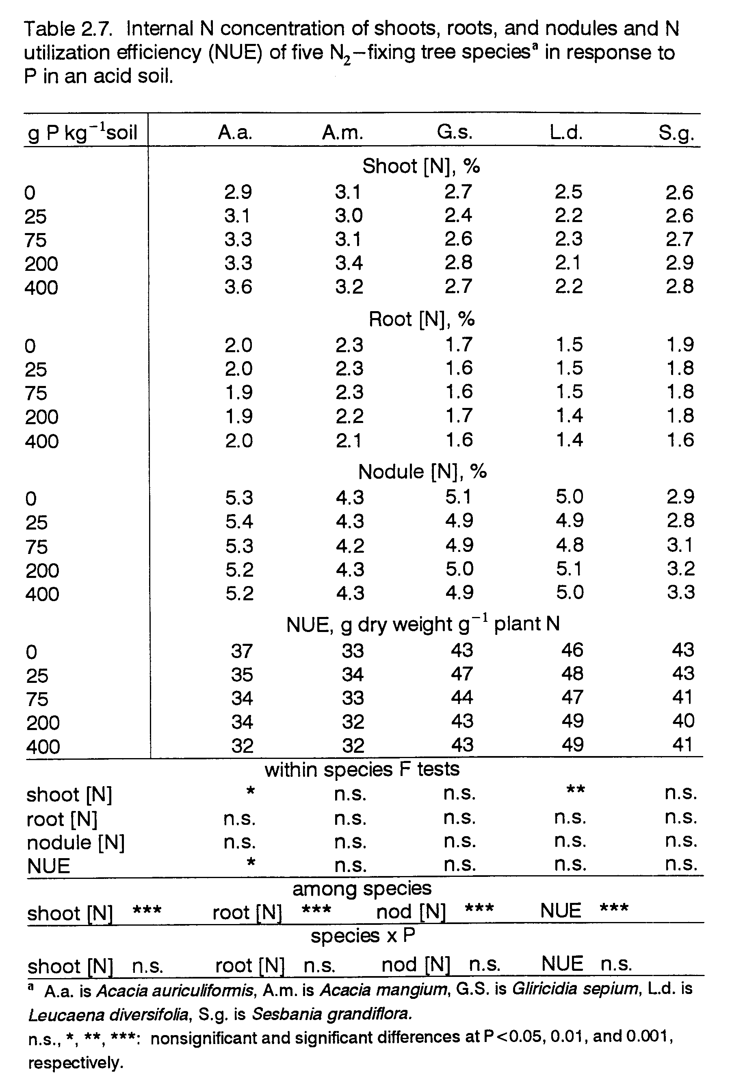
CHAPTER 3. Early growth response to phosphorus and associated differences in root parameters of four fieldplanted nitrogen-fixing tree species.

ABSTRACT
The objective of this paper was to determine the growth response of four field-planted nitrogen-fixing tree (NFT) species to P in an acid soil, and to identify root parameters that are associated with tolerance of P infertility. Acacia auriculiformis (A.a.), Gliricidia sepium (G.s.), Leucaena diversifolia (L.d.), and Sesbania grandiflora (S.g.), were grown at three P levels (0, 50, and 200 kg P ha⁻¹) in an ultisol with pH 4.4. Biomass accumulation data from two harvests at 4 and 8 months after transplanting (MAT) suggested that A.a. was the best adapted species to low-P, acid-soil conditions. It produced as much biomass at 0 P as at 200 P. It was the most productive species at 0 P, and at 8 MAT was even as productive as the largest responsive species at higher P levels. At all P levels, this species had the largest leaf:root ratio. The average root radius (r) of A.a. was the smallest, making its root surface area (RSA) per unit of root weight greater than in other species. However, greater RSA for P absorption did not entirely account for A.a.’s low-P tolerance since its root length density (RLD), RSA per unit of plant weight, and its rate of root infection by vesicular-arbuscular mycorrhizae (VAM) were not ranked the highest among species. That A.a.’s high biomass productivity was associated with its having the lowest nodule biomass suggests that efficient nodule function may explain some of its low-P tolerance.
Growth of G.s., L.d., and S.g. was restricted at low soil P. Sesbania grandiflora was the most sensitive to P infertility at 0 P, but did not respond to P additions beyond 50 P. The sensitivity of S.g. to low P was related to its greater production of stem biomass, to its low RSA per unit of plant dry weight, and to its high ratio of nodule to root weight. Gliricidia sepium and L.d. exhibited more moderate increases in biomass accumulation across all P levels. Root surface area in the top 25 cm of soil of G.s., L.d., and S.g. increased when P supply was limiting and was associated with a relatively greater allocation of biomass to lateral roots at this soil depth. Root radius did not respond to P. Root infection by VAM at 4 and 8 MAT was greater in the P-responsive species than in A.a., and overall, did not change significantly with P treatment.

INTRODUCTION
Several studies have found that plants growing with limited P availability alter growth habits to favor P acquisition from a deficient environment by increasing biomass partitioning to roots (Breeze et al., 1984; Gutschick, 1993; Sanginga et al. 1991), increasing root length (Aboulroos and Nielsen, 1979; Sanginga et al., 1994), and reducing root diameter (Blair and Godwin, 1991; Schenk and Barber, 1979; Taylor and Goubran, 1976). Such growth alterations affect the development of different plant components and the overall performance of the plant. The extent and type of growth alterations displayed by a species depend on its degree of tolerance to low P. In a greenhouse pot experiment (Chapter 2), some NFT species that were less tolerant of low P had proportionately more root biomass than more-tolerant species. Gutschick (1993) proposed that increased biomass investment in roots by P-stressed plants pays off in the long run by delaying P depletion of the rooting zone. For a given P demand, a larger root system necessitates a lower rate of P uptake per unit of root mass. However, root biomass data alone does not sufficiently describe a plant’s P uptake capacity. This chapter examines how different root parameters that determine RSA change in response to P in field-grown trees with varying degrees of low-P tolerance.
The mechanisms by which plants increase RSA are not universally applicable. Some authors have found no effect of P on root thickness (Aboulroos and Nielsen, 1979; Breeze et al., 1984), reduction of root radius with added P (Hallmark and Barber, 1984) or that root length decreases rather than increases as P supply diminishes (Garcia and Ascencio, 1992). The effect of P supply on root morphology can be confounded by changes in root structure that normally occur over time (Blair and Godwin, 1991). For example, Breeze et al. (1984) found that mean root diameters of ryegrass were not affected by P, but did decrease with time. This was attributed to increased production of small lateral roots as the plant aged.
While changes in root structure can increase RSA per unit of root biomass, greater allocation of plant biomass to roots can account for a considerable share of the increase in total RSA. The extent to which different species alter biomass partitioning in response to soil P infertility can have a large impact on their overall performance. Increased biomass allocation to roots restricts development of other plant components. Israel and Rufty (1988) demonstrated that growth limitation of P-deficient soybeans occurred primarily because of restricted leaf development. And a reduction of leaf biomass would very likely yield less photosynthate to drive plant growth. On the other hand, species which have inherently high biomass partitioning to roots may have an advantage on nutrient-poor soils. Sanginga et al. (1991) found that Leucaena leucocephala, a species not adapted to infertile soils, had root/shoot ratios less than half those of Gliricidia sepium, which performed better at lower fertility.
In N₂-fixing plants, the effect on plant growth of competition between nodules and roots for biomass is an important consideration. When P supply is limited, biomass may be preferentially allocated to roots, to the detriment of nodule development (Cassman et al., 1980). However, in soil that is N as well as P limited, nodulation may conceivably be a stronger competitor with root development. In addition to root biomass, nodules may also affect root structure. Cassman et al. (1980) showed, in their study with soybeans, that there was an inverse relationship between nodule mass and total root length.
Other than morphological adaptations, trees may also rely on mycorrhizal associations to enhance P acquisition. The effect of mycorrhizae on P uptake is thought to be via increased surface area for P absorption and via accessing forms of P unavailable to plants (review in Mosse, 1981). Therefore, mycorrhizal plants may have a greater P absorptive capacity than RSA data indicate. Caradus (1981) found that in field soils where VAM are ubiquitous, greater root-hair length in white clover bestowed no advantage in P uptake.
Enhanced nutrient acquisition through increased root surface area and more extensive root systems is particularly important for P due to its relative immobility in the soil. Authors such as Nye and Tinker (1977) and Barley (1970) have shown that the size of the root absorptive surface in conjunction with the ability of roots to extend beyond. P depletion zones in the soil play significant roles in determining P uptake capacity. One hypothesis tested in this paper is that those NFT species less tolerant of P infertility in acid soil alter their growth habit at low P to favor RSA development through: a) relative increases in biomass partitioning to roots, and b) reduced root radius.
To enable tolerance of low-fertility conditions, strategies enhancing nutrient uptake may be coupled with strategies that reduce demand for soil nutrients. Low nutrient demand may be manifested by high internal nutrient use efficiency and/or by slow growth. This paper hypothesizes that species displaying greater low-P tolerance in the field have slower growth rates. Species adapted to higher fertility can increase growth in response to improved fertility, but the low growth potential of plants adapted to infertile sites is generally expressed even under conditions of higher fertility (Aerts, 1990; Mulligan and Sands, 1988).
The objectives of this paper are: 1) to determine the tolerance of field-planted NFT species to P infertility in acid soil in terms of biomass accumulation and partitioning; and 2) to determine whether differences in growth parameters that affect P uptake (such as root development, RSA, r, and VAM infection) are associated with the degree of tolerance to low P fertility.

MATERIALS AND METHODS
Species Selection and Seed Source
Four NFT species representative of a spectrum of P infertility tolerance in acid soil were selected, based on results from the pot experiment presented in Chapter 2. The species were Acacia auriculiformis (A.a.), Gliricidia sepium (G.s.), Leucaena diversifolia (L.d.), and Sesbania grandiflora (S.g.). Of these four species, A.a. appeared to be the most tolerant of low P. It did not respond to P by increasing biomass production. Acacia mangium, which actually appeared to have the greatest low P tolerance in the pot experiment, was not included in the field study because of evidence of root gall nematode infection in the study soil. The intermediate P-responsiveness of G.s. suggests moderate low-P tolerance. Leucaena diversifolia and S.g. were the most restricted by P infertility. A fifth “species” treatment in the experiment was uninoculated G.s. that was used as the reference species to estimate BNF in the four inoculated species (BNF data are presented in Chapter 4). Gliricidia sepium was selected as the BNF reference species because, as the fastest-growing species in the pot experiment, it could provide an estimate of maximum possible N uptake by the slower-growing species.
Seeds of A.a. and L.d. were obtained from the same sources listed in Chapter 2. Gliricidia sepium seeds from Yogyakarta, Indonesia, and S.g. seeds from Magelang, Indonesia, were supplied by the Inland and Foreign Trading Co. in Singapore.
Site Description
The experiment was conducted from June, 1993 to February, 1994 at Hogback experimental site on the island of Maui, Hawaii. The site is at 300 m elevation with mean annual rainfall of 2000 mm and mean annual soil temperature (at 10 cm) of 23°C. The soil characteristics are described in Chapter 2. Soil solution pH at the time of planting was 4.4 (1:1, H₂0). Most probable number determinations of native soil rhizobia for the species were done by a plant infection technique, using a 1:10 (soil:water) dilution series as an inoculant (Somasegaran and Hoben, 1994). Results revealed that only A.a. was nodulated by indigenous soil rhizobia.
Experiment and Treatment Design
Trees were planted in a split-plot design replicated four times. Subplots of A.a., G.s., L.d., S.g., and uninoculated G.s. were grown within three mainplots with P fertilization rates of 0, 50, and 200 kg P ha⁻¹. Phosphorus was added to mainplots as triple super phosphate (TSP, 20% P). Basal nutrients were supplied to all plots at the following rates (kg ha⁻¹): 150 K as K₂SO₄, 30 Mg as MgSO₄, 10 Zn as ZnSO₄·H₂O, 0.5 B as Na₂B₄O₇·1OH₂O, 0.5 Mo as NaMoO₄·2H₂O, and 140 Ca supplied by TSP (14% Ca) at the highest P level and/or by CaSO₄·2H₂O at the lower levels. Sulfate was the covarying anion. Fertilizers were tilled into the soil one week before transplanting.
Plant Culture
Tree seedlings were started from seeds in March, 1993 and grown for two months in a greenhouse at Hamakuapoko, Maui, Hawaii. Seedlings were hardened outdoors two weeks before transplanting to the field site in June, 1993.
Seedling culture in the greenhouse: Seeds were scarified and surface-sterilized as described in Chapter 2 (except for S.g. seeds which were treated by soaking for 30 minutes in concentrated H₂SO₄), then planted in 52 ml-dibble tubes at the rate of three to five seeds per tube. Dibble tubes were filled with Fisons Sunshine Mix No.4, containing peat moss, perlite, dolomitic lime and starter nutrients. Seeds of G.s. were pregerminated in trays of potting mix before being transferred to dibble tubes. Planting was staggered by species, those with slower growth rates planted first, to ensure that all seedlings would be ready for transplanting at the same time. Acacia auriculiformis and L.d. were planted first. Sesbania grandiflora and G.s. were planted three and four weeks later, respectively. Four weeks after planting each species, seedlings were inoculated with rhizobia in yeast extract mannitol broth culture (Vincent, 1970) at 2 x 10⁸ cells per dibble tube. The rhizobial strains used had been identified as effective for these species by Turk (1991) and were: TAL 850 for A.a., TAL 1788 for G.s., TAL 1145 for L.d., and TAL 1114 for S.g. TAL strains are from NifTAL Center, University of Hawaii.
Dibble tubes were thinned to one healthy plant per tube. Ten days after the planting of G.s., all species were switched from being watered with deionized water to being watered with a nutrient solution to enhance nodulation and accelerate seedling growth. The nutrient solution composition was (mM) 0.50 N, 0.48 P, 0.96 K, 0.46 Mg, 1.09 S, 0.58 Ca, 0.12 Fe, 0.04 B, 0.0006 Co, 0.003 Cu, 0.01 Mn, 0.0005 Mo, and 0.009 Zn (Singleton, 1983).
Except for rhizobial inoculation, seeds and seedlings of uninoculated G.s. were treated in the same manner as those of inoculated G.s. with precautions taken to prevent rhizobial contamination. Germination trays were sterilized with a 0.5% sodium hypochlorite solution; dibble tubers and potting mix were steamed for 90 minutes.
Seedlings of A.a. were sprayed with Benlate fungicide (benomyl) to control powdery mildew.
Plant culture in the field: Tree seedlings were selected for uniformity and planted at the field site at the rate of 5000 trees ha⁻¹ (1 m x 0.5 m spacing). Drip irrigation maintained soil moisture at -0.2 bar tension to 50 cm depth for the first two weeks after transplanting. Thereafter, soil moisture tension was maintained above -0.5 bar. Diazanon insecticide to prevent cutworm damage and a preemergent herbicide, Ronstar (oxadiazon), were applied directly after transplanting. Gliricidia sepium suffered some toxicity from the herbicide, and all species displayed signs of transplant stress. During the eight-month course of the field experiment, weeds were controlled by Roundup (glyphosate) and hand-weeding; Chinese Rose Beetles on A.a. and S.g. and psyllids on L.d. were controlled with Orthene (acephate); powdery mildew on A.a. was controlled with Benlate, Bravo W-75 (chlorothalonil), and Bravo-Ridomil (chlorothalonil and metalaxyl).
Harvests and Plant Analyses
At 4 and 8 months after transplanting (MAT), nine trees in a randomly selected 4.5 m² area within each subplot were harvested. Trees were cut at the stem base and stems (above-ground support tissue, including leaf rachises) were separated from leaves (or leaflets, in the case of compound leaves).
Crown roots plus nodules were retrieved from an area of soil about 30 cm deep and in a 30 cm radius around the base of three of the nine trees harvested. Nodules were retrieved manually from roots and surrounding soil. Nodules and roots were then cleaned with water.
At both harvest times, root samples were collected for assessment of VAM infection. About a 1 g fresh subsample of the finest roots was taken from the crown roots of each subplot. These subsamples were stored in formalin-acetic acid-alcohol solution and later analyzed for VAM infection as described in Chapter 2. Estimates of lateral-root, length and weight were obtained from soil core samples. Soil cores were taken in equal numbers from inter- and intra-row points, at two soil depths (0-25 and 25-50 cm) throughout the harvest area. The volume of soil from which lateral-root samples were extracted was 402 cm³ (eight soil cores) at the 0-25 cm depth, and 302 cm³ (six soil cores) at the 25-50 cm depth. Roots were extracted from the soil with a hydropneumatic elutriation machine (Smucker et al., 1982), then stored in a 15% propanol solution. Length of these roots was determined using the gridline intersect method of Tennant (1975), after samples had been picked clean of dead roots and other organic matter. Roots were weighed fresh, then rinsed of propanol and dried at 65°C.
Calculations
The following calculations were made to determine plant growth rate and parameters of lateral root development for each species:
1. Root length density (RLD) = RL (V_{soil})⁻¹, where RL = root length in cm and V_{soil} = soil volume in cm³.
2. Root radius (r) = (V_{roots} (π RL)⁻¹)^{1/2}, Hallmark and Barber (1984), where V_{roots} = root fresh wt (fresh root density)⁻¹. Fresh root density was assumed to be 1 g cm⁻³.
3. Root surface area (RSA) = 2πrRL, expressed as RSA(V_{soil})⁻¹.
Statistical Analysis
Statistical analyses were performed as described in Chapter 2, except that the SAS program was for a split plot design within each harvest. Statistical comparisons between harvests were not made.

RESULTS
Biomass Accumulation
Response patterns were similar to those observed in the pot experiment of Chapter 2. Acacia auriculiformis did not respond to P in terms of total biomass production at either 4 or 8 MAT, while G.s., L.d., and S.g. all increased biomass production with P supply (Fig. 3.1). Acacia auriculiformis was the largest species in the field at 0 P at both sampling times, and by 8 MAT it was as productive as the largest responsive species at 50 and 200 P. Only S.g. at 50 P and G.s. at 200 P had biomass equivalent to A.a. at 8 MAT. Gliricidia sepium and L.d. had intermediate increases in growth with P, while S.g. had the greatest relative biomass response to 50 P, but showed no additional increase at 200 P. The small response to P of uninoculated G.s., compared to inoculated G.s. illustrates the N infertility of the soil, and the degree to which inoculated trees in this soil relied on BNF as a source of N.
Biomass Partitioning
Allocation of biomass to different plant components above and below ground in response to P is shown in Table 3.1 for all the species.
Partitioning to leaves. Partitioning to leaves tended not to change within species across P levels. However, there were large differences among species. Acacia auriculiformis had the highest proportion of biomass in leaves. At 4 MAT more than 50% of its dry weight was in leaves, while the percentages for G.s. and L.d. were around 40 and 25, respectively. Sesbania grandiflora was the only species which registered a significant (P<0.05) change in the percent of biomass allocated to leaves at 4 MAT. At 50 and 200 P, its dry weight fraction in leaves was lower than at 0 P, and was the lowest of all species. The fraction of biomass allocated to leaves declined in all species over time. Acacia auriculiformis, with the largest leaf biomass fraction, displayed the smallest (ca. 30%) decline in this fraction over time. While S.g., with the smallest leaf biomass fraction, experienced the largest decline (ca. 65%) in this fraction over time. Because of the different rates of change in partitioning to leaves, the gap between A.a. and the other species for this parameter was wider at: 8 than at 4 MAT.
Partitioning to stems. Biomass partitioning to stems did not consistently increase with P, but showed a greater tendency to do so in the responsive species. However, as trees grew larger over time, stem biomass fractions increased in all species. Biomass partitioning to stems was highest in S.g. at both 4 and 8 MAT, and increased at 50 P, concurrent with the decrease in allocation to leaves. Stem biomass fractions were smallest in A.a. and G.s.
Partitioning to crown roots. Dry weight partitioned to crown roots tended to decrease at higher P levels in all species except G.s. The largest crown root biomass fraction was in G.s., and the lowest in A.a. Acacia auriculiformis displayed the smallest and S.g., at 0 P, the largest increase in biomass allocation to crown roots over time.
Partitioning to lateral roots. Lateral root biomass was estimated at two soil depths, 0-25 cm and 25-50 cm. As P supply increased, decline in the fraction of biomass partitioned to roots in the top 25 cm was significant only in G.s. at both times, and in S.g. at 4 MAT. Acacia auriculiformis had the lowest percentage of dry weight in lateral roots at 0-25 cm at 4 MAT, and only S.g. had a lower percentage at 8 MAT. However, A.a. had a greater proportion of its lateral root biomass at the 25-50 cm depth than any other species. The responsive species all had more than double the quantity of roots in the top 25 cm of soil than in the deeper layer (Table 3.2). This is expected since soil analysis showed that extractable P was twice as high at 0-25 cm than at 25-50 cm for all P levels (see Table 3.3). But A.a.’s roots were more evenly distributed between the 2 soil depths. The percent of biomass allocated to roots tended to decline at both depths over time. The reduction was largest in S.g. which, at 8 MAT, had the lowest biomass fraction in lateral roots at both depths.
Partitioning to nodules. Dry weight partitioning to nodules remained relatively constant across P levels, but differences among species were highly significant (P<0.001). The largest and smallest fractions of biomass in nodules at both sampling times were in S.g. and A.a., respectively.
The biomass fraction in nodules tended to decline over time, more noticeably so in the responsive species.
Partitioning between leaves and roots. At both harvest times, the dry weight ratio of leaves to roots (crown plus lateral roots) was considerably greater in A.a. across P levels than in the P-responsive species (Table 3.4). Changes in this ratio across P levels were not significant, but for all species, it declined over time.
Partitioning between roots and nodules. Data on the ratio of nodule dry weight to the combined dry weight of crown roots and lateral roots to a 50 cm depth are presented in Table 3.4. The ranking of this parameter among inoculated species follows the ranking of nodule dry weight. Sesbania grandiflora, with the largest nodule biomass, and A.a., with the lowest nodule biomass, possessed the highest and lowest dry weight ratio of nodules to roots, respectively.
Root Development and Morphology
Root length density. Overall, the P response of RLD (Table 3.5) and its rankings among the species followed similar trends as did lateral root dry weight (Table 3.2). Root length density showed some tendency to increase with added P, in the top 25 cm of soil (P<0.08), though this trend was not consistent over time. At the 0-25 cm soil depth, RLD was greatest in A.a. and G.s. In deeper soil (25-50 cm), A.a. had the greatest RLD. The differences in RLD between A.a. and the other species were greater at 8 MAT, when the RLD of A.a. was more than double that of the second-ranked species, G.s., at all P levels. The rank of RLD at 0-25 cm, 4 MAT, was lower in S.g. than its rank for root dry weight. At 8 MAT, S.g. had among the lowest RLD of all species.
Root radius. Root radius (Table 3.5) calculated from root fresh weights was inversely correlated with another measure of root thickness, RL(root dry wt.)⁻¹, with values for r² ranging from 0.71 to 0.84 (data not shown).
Acacia auriculiformis roots were generally thinner than those of any other inoculated species across P levels and over time. The average radii of A.a., G.s., and L.d. roots at 0-25 cm increased slightly between harvests, while that of S.g. declined slightly. Only L.d. and S.g. displayed significantly smaller r of roots at 0 P, and this response occurred at the 25-50 cm soil depth, 4 MAT. For roots at the 0-25 cm soil depth there was no significant P response of root radius at 4 MAT; and at 8 MAT, only L.d. displayed a significant (P<0.05) response (r was greatest at 0 P). At 4 MAT, S.g.’s roots in the top 25 cm of soil were considerably thicker than in any other species.
Roots, for all species except S.g., displayed a slight trend towards increasing radius over time, at both soil depths measured. Sesbania grandiflora roots in the top 25 cm of soil were thinner at 8 MAT than at 4 MAT.
Root surface area. For the most part, RSA (Table 3.6) followed the same P response trend and inter-species rankings as did root dry weight. Sesbania grandiflora was the one notable exception. At the time of the first harvest, it had the greatest root dry weight at 0-25 cm, but because of the thickness of these roots, their surface area declined relative to the other species. Also, because A.a. had the thinnest roots, its RSA was comparatively higher than was its root dry weight; though this relative increase in RSA was not sufficient to affect its rank among the species.
Because the species were so different in size, it was important to look at RSA in terms of the amount of plant biomass it was required to support. To do this, RSA at the two soil depths was summed and expressed on a per unit of plant dry weight (including roots) basis (Table 3.6). The P-response of this parameter not significant in all cases except for S.g. at 4 MAT, which increased RSA(plant dry wt.)⁻¹ at low P. Sesbania grandiflora had the lowest and G.s. the highest RSA(plant dry wt.)⁻¹ ratio of all species. This ratio was greater at 4 MAT than it was at 8 MAT for all species.
Root VAM infection. The rate of root infection by indigenous soil VAM (Table 3.7) did not change much across P levels, but was significantly different (P<0.01) among the species. Acacia auriculiformis displayed the lowest, and L.d. the highest VAM infection at both 4 and 8 MAT.

DISCUSSION
Acacia auriculiformis, which did not respond to P fertilization by increasing biomass production, demonstrated the greatest degree of tolerance to low P availability. It grew slowly only during the initial establishment phase. By the eighth month, A.a. had the fastest growth rates, and its accumulated biomass was greater than or on par with that of the P-responsive species. The superior low-P tolerance of A.a., which must have therefore depended on high efficiencies of nutrient acquisition or utilization, is evidenced by its biomass partitioning and rooting patterns.
Greater root growth at the expense of leaf development can restrict whole-plant growth by reducing photosynthetic capacity. However, in A.a., high productivity was maintained in this low-P soil with a relatively low investment of biomass in roots and greater leaf development. Possible implications are that A.a.: 1) had a very low internal P requirement for growth, 2) roots had a high efficiency of P uptake, and 3) roots had a relatively high surface area per unit weight of root. The first two are investigated in Chapter 4. With reference to RSA development, A.a.’s roots had the smallest r of all species, giving this species relatively greater RSA per unit of root weight. However, due to the influence of relatively low biomass partitioning to roots, RSA and RSA per unit of plant dry weight were not consistently the greatest in A.a. when this species had the greatest growth. The implication is that root morphology was not solely responsible for A.a.’s low-P tolerance.
In perennial species, VAM often plays an important role in P acquisition. Manjunath and Habte (1991) demonstrated an inverse relationship between VAM dependence and root thickness in Leucaena and Sesbania species. Data from this study support this assertion. The species with the smallest r, A.a., had the lowest rate of VAM infection.
The three responsive species differed from A.a. in that their biomass partitioning favored stems and roots over leaves (It should be noted, however, that by the second harvest time both G.s. and S.g. had experienced seasonal leaf loss). At all P levels, the responsive species had larger fractions of biomass invested in lateral roots in the 0-25 cm soil layer, where P availability was highest than did A.a. And when P supply was deficient, at 0 P, the fraction of biomass in shallow lateral roots increased more in the responsive species than in A.a., implying greater soil P demand and/or less efficient P uptake by roots of the responsive species.
The responsive species used their resources less efficiently to increase RSA than did A.a. Increased biomass partitioning to shallow lateral roots at 0 P was largely responsible for the higher RSA per unit plant dry weight that the responsive species displayed at 0 P. Root thickness in the top 25 cm of soil did not change with P supply and therefore did not contribute to changes in RSA. However, in the 25-50 cm soil layer, roots of the responsive species did tend to be thinner when P was limiting. These apparent trends in root development in G.s., L.d., and S.g., though often not significant, are in agreement with the hypothesis that one strategy for coping with low P in species adapted to higher P fertility is to increase RSA through reduced r and through biomass partitioning favoring roots. The three responsive species, which had thicker roots than A.a., apparently made a greater investment into developing surface area for P absorption via symbiosis with VAM. They had significantly higher levels of root infection by VAM than did A.a.
Of the P-responsive species S.g. was the most responsive to improved P fertility. That S.g.’s growth was the most restricted by P stress may partly arise from its root structure. Development of RSA in this species appeared to face greater limitations than in the other species. Lateral roots had the largest r, yielding less RSA per unit of root weight. Sesbania grandiflora’s RSA development may have also been impaired by the high ratio of nodule to root biomass in this species.
The low-P sensitivity of S.g., as well as of L.d., was associated with comparatively small fractions of leaf biomass and large fractions of stem biomass. As much as 70% of S.g.’s biomass was allocated to stems at 8 MAT, the highest fraction of any species.
In this soil which was N- as well as P-limited, tolerance of the BNF symbiosis to low P availability was critical to the low-P tolerance of NFT growth. It appears that part of A.a.’s success was attributable to the low-P tolerance of its BNF symbiosis. This was the only species with the same level of nodulation at 0 P as at 200 P. It also had the lowest biomass allocation to nodules implying that this species had a low internal N requirement and/or a very efficient BNF symbiosis in terms of N₂ fixed per unit weight of nodule tissue. Also, A.a.’s inherently low nodule weight gave it the lowest ratio of nodule to root biomass, indicating that root development of this species was the least restricted by nodulation. In contrast, the higher fraction of biomass partitioned to nodules in G.s., L.d., and S.g. implies greater competition between nodulation and the development of other plant components in these species.
In conclusion, sensitivity to low P fertility in G.s., L.d., and S.g. was associated with: 1) greater biomass partitioning to roots, especially to lateral roots in the top soil layer where P availability was higher; 2) lower leaf:root biomass ratios; 3) higher VAM infection rates; 4) less RSA per unit of root dry weight; and 5) higher nodule:root biomass ratios. The first three responses served to increase total RSA available for P absorption but were also associated with restricted whole-plant growth. The fourth and fifth factors limited RSA development, the fifth factor suggesting that the BNF symbioses of the responsive species were less tolerant of low-fertility.
Acacia auriculiformis’ low-P tolerance apparently did not depend on enhanced P acquisition by means of a larger RSA. Despite having the thinnest roots, A.a. did not have the largest RSA per unit of plant dry weight. This held true even when A.a. produced more biomass than any other species. That A.a. demonstrated the greatest biomass productivity with the highest leaf:root biomass ratio, but without the largest RSA for P uptake, suggests that A.a. had higher efficiencies of P uptake and/or of internal P utilization. Low nodule:root biomass ratios in this species also imply more efficient resource use by nodules for N₂-fixing activity, and/or a lower internal N requirement for growth. Acacia auriculiformis’ low-P tolerance was also associated with high growth rates which does not support the hypothesis that low nutrient demand through slow growth is part of the strategy of inherent low-P tolerance.
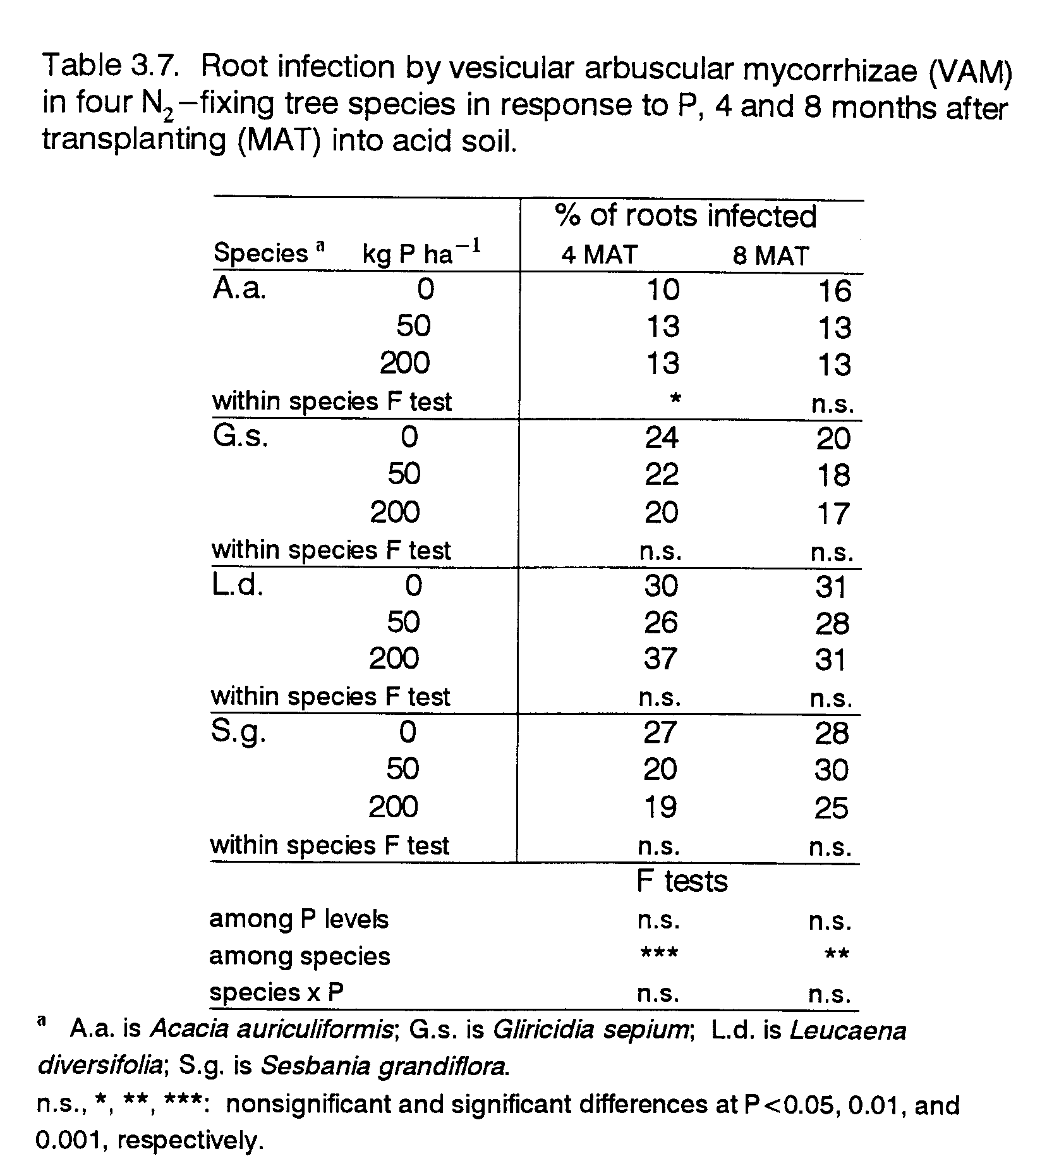
CHAPTER 4. Utilization efficiency of P, N, leaves, roots, and nodules in four nitrogen-fixing tree species in response to P in an acid soil.

ABSTRACT
Elements of plant strategies for surviving low-fertility conditions include greater efficiencies of nutrient use for biomass production, of nutrient uptake, and of biological nitrogen fixation (BNF). Nutrient utilization and plant function efficiencies of four nitrogen-fixing tree (NFT) species, Acacia auriculiformis (A.a.), Gliricidia sepium (G.s.), Leucaena diversifolia (L.d.), and Sesbania grandiflora (S.g.), in a low-P acid soil were assessed in a field experiment. It was hypothesized that low-P tolerance in these species was associated with the following: 1. greater internal phosphorus and nitrogen use efficiency (PUE and NUE), defined as dry matter production per unit of plant P or N; 2. greater P efficiency for BNF (BNFPE), defined as N₂ fixed per unit of plant P; 3. greater specific nodule activity (SnA), defined as N₂ fixed per unit of nodule dry weight; 4. greater net assimilation rate (NAR), defined as dry-matter production per unit of leaf area per unit of time; and 5. greater P uptake efficiency (PupE), defined as plant P per unit of root surface area. The four species were grown at 0, 50, and 200 kg P ha⁻¹ and harvested at 4 and 8 months after transplanting (MAT). Acacia auriculiformis, the non-responsive species, displayed the greatest low-P tolerance. The other species all increased growth with P fertilization. Sesbania grandiflora displayed the greatest responsiveness to P, while the P-response of G.s. and L.d. was more moderate.
The first hypothesis was partly supported by A.a.’s performance. This species had the highest whole-plant PUE at 4 MAT, though not at 8 MAT. However, at both times, P and N concentrations of leaves were the lowest in A.a., and leaves comprised 53 and 35% of its total biomass at 4 and 8 MAT, respectively. The most responsive species, S.g., exhibited the greatest PUE for whole-plant growth at 8 MAT. The second and third hypotheses were also supported. Acacia auriculiformis’ relatively high productivity at 0 P, when P and N were limiting, was associated with a high BNFPE and the highest SnA. However, high NAR and PupE were not associated with the low-P tolerance of this species.
In the responsive species, P seemed to have a greater effect on leaf function than on leaf morphology. At 0-4 MAT, P fertilization brought about greater increases in NAR than in specific leaf area (SLA, leaf area per unit leaf dry weight). And leaf area ratio (LAR, leaf area per unit of whole-plant dry weight) remained relatively constant across P levels. Greater P and carbon requirements of the BNF symbiosis also appeared to restrict the growth of the responsive species at low P. They all had lower SnA than A.a.; and L.d. and S.g. also had comparatively lower BNFPE. Sesbania grandiflora’s sensitivity to low P fertility was associated with high P demand of stems and reduced specific leaf area (SLA).

INTRODUCTION
The restriction of plant growth by P deficiency is often associated with decline in the function of plant components like leaves, roots, and nodules. Studies with barley (Aboulroos and Nielsen, 1979) and white clover (Blair and Godwin, 1991) demonstrated that P uptake per unit of root length, or surface area was reduced at low P supply. Gates (1974) found that reduced P availability resulted in lower SnA of Stylosanthes humilis. In some cases, P stress has been found to restrict nodulation and BNF to a greater extent than plant growth per se (Israel, 1987; Pongaskul and Jensen, 1991). Phosphorus deficiency also limits plant growth by reducing the rate of photosynthesis (Fredeen et al., 1989; Sawada et al., 1983), NAR (Kirschbaum et al., 1992; Mulligan and Patrick, 1985), leaf expansion and SLA (Fredeen et al., 1989; Kirschbaum et al., 1992).
Many plant genotypes increase efficiency of nutrient utilization when grown under nutrient-limited conditions. Greater nutrient use efficiency for biomass production with reduced nutrient supply was observed in sunflower (Gutschick, 1993), in Eucalyptus (Kirschbaum et al., 1992), and in soybean (Israel and Rufty, 1988).
Restriction of plant function and increased efficiency of nutrient use in response to reduced P availability have been found in plant genotypes adapted to relatively higher fertility. Strategies for survival of low nutrient availability differ between genotypes adapted to low-fertility habitats and those adapted to fertile conditions (Chapin, 1980; Haynes et al., 1991). Some of the differences between genotypes adapted to different fertility conditions can be explained by the different selection pressures applied to species in their natural habitats. In a low-nutrient habitat, traits promoting long-term survival, like slow growth and nutrient conservation, give species a competitive advantage (Aerts, 1990; Blair and Wilson, 1990; Mulligan and Sands, 1988; Poorter, 1989). Such strategies permit plants to tolerate low fertility without having to develop highly efficient plant functions such as nutrient uptake and utilization (Blair and Wilson, 1990; Chapin, 1980). For example, species that are tolerant of low fertility have been found to actually have higher internal nutrient concentrations than species adapted to high fertility when both are grown at low fertility (Aerts, 1990; Chapin, 1980; Mulligan and Sands, 1988). Also, in studies with white clover and oats, genotypes adapted to low fertility did not have greater efficiency in P uptake by roots (Blair and Wilson, 1990; Haynes et al., 1991).
However, plant species adapted to poor fertility may also exhibit greater efficiencies for some plant functions (Chapin, 1980). In studies with loblolly pine (Crawford et al., 1991), and oats (Haynes et al., 1991), genotypes from low-fertility sites displayed higher nutrient use efficiencies. It also seems reasonable to expect that tolerance of low P fertility in some NFT species may be associated with greater efficiencies of leaf, root and nodule function for net carbon assimilation, P uptake, and BNF, respectively.
In addition to physiological adaptations to cope with low P, plants may also alter morphology. This issue was addressed to some extent in the previous chapter with respect to root morphology and its affect on P acquisition. In this chapter, leaf morphology is discussed. Leaf morphology is critical to plant growth since it plays a significant role in the development of photosynthetic surface. In a study with Eucalyptus seedlings, Kirschbaum et al. (1992) found that leaf expansion and SLA increased with P supply. They showed that these adjustments in leaf structure as well as greater efficiency in leaf function (assimilation rate of carbon per unit of leaf area) were associated with increased biomass production as P supply went up. The importance of the P effect on leaves in determining whole-plant P response has been demonstrated by authors who found that leaf area development was more severely restricted by low P than was biomass accumulation (Ahlawat and Saraf, 1983; Israel and Rufty, 1988; Fredeen et al., 1989). Studies with soybean (Fredeen et al., 1989) and pigeon pea (Ahlawat and Saraf, 1983) also found that low P had a lesser effect on leaf function than on leaf morphology. Leaf area can be restricted at low P by reduced leaf expansion (Fredeen et al., 1989; Kirschbaum et al., 1992) and by increased leaf thickness (Fredeen et al., 1989; Kirschbaum et al., 1992).
For this study, it was hypothesized that the NFT species which displayed greater tolerance of low P availability would be more efficient in their use of P and N, and of leaf, root and nodule tissue. In other words, they would exhibit greater PUE, NUE, BNFPE, NAR, SnA, and PupE. In testing these hypotheses, the objectives of this paper are: 1) to identify differences in P and N utilization efficiency among species that are associated with their low-P tolerance in acid soil; and 2) to determine whether species tolerant of P infertility have greater efficiencies of leaf, root, and nodule utilization for plant growth.

MATERIALS AND METHODS
Materials and methods (except for calculations) described in Chapter 3 also apply in this chapter, with the following additions.
Nutrient Analysis
All plant component samples were dried at 65°C and analyzed for P and N as described in Chapter 2.
Specific Leaf Area Determination
At each harvest, random leaf subsamples were taken from each subplot for specific leaf area determination (cm² leaf area g⁻¹ leaf dry weight). Leaf area did not include area of the rachis in species with compound leaves (G.s., L.d., and S.g.). Leaves of L.d. and S.g. were pressed in between plastic sheets to prevent closure of leaflets. Leaf area was measured using a LI-3100 area meter (LI-COR, Inc., Lincoln, Nebraska), then leaves were dried at 65°C to a constant weight.
Estimation of Biological Nitrogen Fixation
The amount of N₂ fixed was estimated for each of the four inoculated species at all P levels with the difference method (Peoples et al., 1989), using uninoculated G.s. as the reference species:
N₂ fixed = N_{I} - N_{U},
where N_{I} is whole-plant N measured in inoculated species, and N_{U} is whole-plant N measured in uninoculated G.s.

Calculations
The following calculations were made to evaluate nutrient and tissue utilization efficiencies:
1. P utilization efficiency, PUE = W (P in plant)⁻¹, where W = whole-plant dry weight.
2. N utilization efficiency, NUE = W (N in plant)⁻¹.
3. Per cent of plant N derived from fixation, %Ndfa (defined in Chapter 2).
4. BNF P efficiency, BNFPE = N₂ fixed (P in plant)⁻¹.
5. Specific nodule activity, SnA = N₂ fixed (nodule dry weight)⁻¹.
6. Whole-plant leaf area, LA = SLA (leaf dry weight per plant), where SLA is specific leaf area.
7. Net assimilation rate, NAR = RGR (LAR)⁻¹, where RGR is relative growth rate and LAR is average leaf area ratio. RGR = (ln W₂-ln W₁) (t₂-t₁)⁻¹, where W is whole-plant dry weight, t is time in months, and the subscripts 1 and 2 are the start and end, respectively, of each time interval. RGR was calculated for 2 intervals, 0-4 and 4-8 MAT. Plant dry weight at 0 MAT is presented in Appendix B.
LAR = [LA₁(W₁)⁻¹ + LA₂(W2)]2⁻¹.
NAR was calculated for two time intervals, 0-4 and 4-8 MAT. While seedling dry weight at 0 MAT was measured and used to calculate RGR at 0-4 MAT, leaf area at planting was not measured and was estimated to be 0 for calculation of LAR at 0-4 MAT.
8. P uptake efficiency, PupE = P in plant (RSA)⁻¹, where RSA is root surface area (defined in Chapter 3).

RESULTS
Phosphorus Use Efficiency
At 4 MAT, whole-plant PUE of A.a. was the highest of all species (Table 4.1). Acacia auriculiformis’ leaf P concentration, at 0.13%, was lower than that of any other species (Table 4.2), which is important since A.a. produced proportionately more leaves than the other species (>50% at 4 MAT) (Table 3.1). Internal P concentrations of A.a.’s stems, roots, and nodules were also comparatively low at 4 MAT. By 8 MAT, A.a.’s whole-plant PUE was lower than that of the responsive species. The P-responsive species had greater increases in biomass partitioning to low-P components (stems and crown roots) over time than did A.a. Sesbania grandiflora, which displayed the highest whole-plant PUE at 8 MAT, had stem and crown root tissue with the lowest P concentrations, as well as a greater stem biomass fraction than any other species.
Phosphorus use efficiency tended to decline at higher rates of P fertilization, with the greatest decline occurring in S.g. at 4 MAT, and in L.d. and S.g. at 8 MAT. Despite the steep decline in S.g.’s whole-plant PUE, this species had the largest relative increase in biomass production between 0 and 50 P (Figure 3.1). At 200 P, P assimilation (Table 4.3) increased in S.g. with no additional biomass increase.
Nitrogen Use Efficiency
Overall, NUE (Table 4.1) tended to follow similar P-response trends as did biomass production (Fig. 3.1). It increased when biomass production increased (as for G.s. and for S.g. at 50 P) and remained constant when there was no change in biomass production (as for A.a. and for S.g. at 200 P). Like PUE, NUE also increased over time in all the species.
Sesbania grandiflora had the highest whole-plant NUE which increased with 50 P. Stems and crowns of S.g., which constituted the bulk of its biomass, had among the lowest N concentrations (Table 4.4). Leaf N concentrations were highest in S.g., but this species also had the smallest leaf biomass fraction.
Acacia auriculiformis and G.s. exhibited the lowest NUEs. Acacia auriculiformis had a comparatively low NUE because, its leaf N concentration, despite being the lowest at 3%, was appreciably higher than stem and crown root N (between 0.6% and 1.7%) of all species.
Biological Nitrogen Fixation
N₂ fixed. The P-response trends and inter-species rankings of N₂ fixed (Table 4.5) were similar to those of biomass production. Plants that were larger fixed more N₂. At 4 MAT, the highest ranked species at 0 P was A.a., while S.g. was highest ranked at 50 and 200 P. At 8 MAT, A.a. trees were the largest and fixed the most N₂ at all P levels.
Specific nodule activity. Acacia auriculiformis, the species with the smallest nodule mass (Table 3.2) and the highest level of N₂ fixed, possessed SnA (Table 4.5) many times greater than in the other species, at both 4 and 8 MAT. Sesbania grandiflora, which had the largest nodule mass, exhibited the lowest SnA. Specific nodule activity did not change as P fertility increased, except for in L.d. and S.g. At 8 MAT, SnA in these species declined (P<0.08) with increasing P supply. There was no consistent trend of change in SnA over time.
Biological nitrogen fixation P efficiency. The efficiency of P use for BNF was determined by calculating BNFPE (Table 4.5). Acacia auriculiformis had the highest BNFPE at 0 P. Leucaena diversifolia and S.g. were the lowest-ranked species for BNFPE. As P supply increased, BNFPE decreased in L.d. at 8 MAT, and in A.a. and S.g. (P<0.1), but remained the same in G.s. The P efficiency of BNF decreased over time for every species except G.s.
Leaf Use Efficiency
Leaf area. Specific leaf area indicates the amount of photosynthetic area plants derive per unit investment in leaf biomass. Acacia auriculiformis had the lowest SLA (Table 4.6). Despite having the highest leaf biomass (Table 3.2), at 4 MAT A.a. did not have the largest leaf area (Table 4.7) when P fertility increased. Sesbania grandiflora had the highest SLA, which was associated with low biomass partitioning (5-7% at 8 MAT) to leaves. Specific leaf area increased in S.g. with the addition of 50 P. This response was less evident in L.d. (P<0.1) and not significant in G.s. at 8 MAT.
Net assimilation rate. Net assimilation rate is an index of how efficiently leaf area is utilized by the plant for growth. A simplified determination of NAR, used in this paper, assumes that leaf area is linearly related to total biomass (Hunt, 1978). Linear correlation between these two parameters was higher for data from the first than the second harvest period. Seasonal leaf drop in some of the species may have at least partly accounted for the lower correlation of data from the second harvest. However, linear correlation coefficients for all species at both harvest times were significant (P<0.01).
Improving P fertility significantly (P<0.05) increased NAR (Table 4.6) of two responsive species (G.s. and S.g.), at 0-4 MAT, but had no effect on the NAR of A.a. or L.d. Leucaena diversifolia displayed the highest NAR at both time intervals, indicating that this species compensated for its low leaf area by having a higher leaf area use efficiency for growth. Gliricidia sepium had the lowest NAR at 0-4 MAT. The NAR of each species was considerably higher during the initial growth phase at 0-4 MAT than at 4-8 MAT. This reduction in NAR over time was associated with a similar decline in RGR (Table 4.8).
Phosphorus Uptake Efficiencv
Increased efficiency of P uptake by roots with improved P fertility was apparent in the responsive species L.d. and S.g. (P<0.06), but not in G.s. (Table 4.9). Among the P-responsive species, higher PupE was associated with smaller RSA (Table 3.6). Sesbania grandiflora, with the highest PupE had the smallest RSA, while the opposite was true for G.s. This trend was not evident in A.a. which possessed a relatively small RSA but also had an intermediate PupE.
DISCUSSION
Plants adapted to nutrient-deficient sites often tolerate low fertility by virtue of low external nutrient requirement, and not because of some inherent greater efficiency of nutrient uptake or utilization (Aerts, 1990; Blair and Wilson, 1990; Haynes et al., 1991). Many such plants exhibit slow growth rates (Blair and Wilson, 1990), and may even have higher internal nutrient concentrations (Mulligan and Sands, 1988) and/or lower nutrient uptake capacities (Chapin, 1980). However, some species may adapt to low nutrient supply by having greater efficiency in the use of nutrients for plant growth and development, and in the function of plant components like leaves, roots and nodules. For example, Sanginga et al. (1994) found that differences in the growth of Gliricidia sepium provenances at low P was largely related to differences in PUE. The present study showed that the species which demonstrated the greatest degree of low-P tolerance, A.a., had the highest PUE for leaf production, and the highest SnA, thereby supporting some of the hypotheses put forward in this chapter.
The most salient feature of A.a. with respect to P use was the high fraction of total P held in leaves. Greater than 60 and 40% of total plant P was in leaves at 4 and 8 MAT, respectively. None of the other species had such high rates of P allocation to leaves. Despite having the highest fraction of total plant P in its leaves, A.a. had the lowest leaf P concentration of all species. Low levels of nutrients in leaves may be an adaptation of trees for surviving low fertility by reducing nutrient loss (Aerts, 1990). If green leaves have a lower nutrient concentration, then there is less nutrient loss as a result of any retranslocation inefficiencies, herbivory, or other natural disturbances. Low litter production is another adaptation for reducing nutrient loss due to inefficiencies of retranslocation (Aerts, 1990; Chapin 1980). Litter production was not quantified in this study, but A.a. did appear to generate relatively less litter than either G.s or S.g.
Aerts (1990) found that two evergreen species from low-fertility habitats had slower growth rates and lower nutrient use efficiency than a deciduous species. This was attributed to low nutrient turnover, due to the production of long-lived leaves and woody stems. Acacia auriculiformis did have one of the lowest whole-plant PUEs at 8 MAT. It also displayed the slowest growth of all species at high P at 4 MAT, but, by 8 MAT, it was the largest, or among the largest, species at all P levels. The reason for A.a.’s relatively high productivity may lie in its low internal leaf requirement for P and N. Therefore, even though nutrients in leaves and stems may have a low turnover rate, A.a. may be able to sustain high leaf production with relatively low new P and N inputs from the soil and BNF, respectively.
Between 4 and 8 MAT, A.a. had the greatest increase in the fraction of plant P allocated to stems of all species. The result was a near-even distribution of P between leaves and stems at 8 MAT. In a comparison of Eucalyptus species, Mulligan and Sands (1988) found that those species adapted to lower-fertility invested a greater fraction of acquired P into stems. Storage of nutrients in stems has been presented as a long-term survival strategy for perennial species in nutrient-deficient conditions because: 1) stored nutrients can be later remobilized for new growth (Chapin, 1980), and 2) checking P transport to photosynthetic tissue until the fulfillment of a basal root demand ensures that growth does not result in overdilution of the limiting nutrient (Mulligan and Patrick, 1985b).
Acacia auriculiformis possessed one of the lower whole-plant NUEs and fixed more N than the other species. The large amount of N derived from BNF was associated with high SnA and BNFPE. Acacia auriculiformis’ high SnA appeared to be an inherent characteristic, not changing significantly across P treatments. On the other hand, BNFPE was partly a function of P availability. Phosphorus was used most efficiently for BNF at 0 P.
Neither NAR or PupE of A.a. were relatively high enough to account for the low-P tolerance of this species. Of the parameters measured, high PUE for leaf production and BNF, and the high efficiency of nodules for N₂-fixation in A.a. were most closely associated with the greater growth of this species in P-deficient, acid soil.
Evidence that A.a.’s non-responsiveness to the range of P treatments in this study is indeed an indication of low-P tolerance, and not of a higher minimum P requirement for growth, lies in the fact that species known to have higher fertility demands (L.d. and S.g.) did respond to the P treatments. Also, A.a. trees in the field appeared healthier and more vigorous than any of the other species.
Compared to A.a., the other species had lower fractions of total plant P in leaves and higher fractions in roots. Sesbania grandiflora also partitioned a greater share of plant P to stems than did A.a., and held larger amounts of P in its stem tissue than the other responsive species. At 8 MAT, the amount of P in S.g.’s leaves was less than half that in its stems. Since S.g. stems had the lowest P concentrations, the higher share of P in the stems of this species arose from its large biomass partitioning to stems.
The PUE and NUE of S.g. for whole-plant biomass production were the highest among all species at 8 MAT. This was largely associated with the predominance of stem tissue with very low P and N concentrations. Though greater biomass production per unit of nutrient is often found in plants adapted to low-nutrient conditions (Kemp and Blair, 1991), species adapted to higher fertility may be competitive in their habitats by virtue of fast growth enabled by high nutrient use efficiency (Aerts, 1990; Haynes et al., 1991; Mulligan and Sands, 1988).
In this study, low P had a greater effect on leaf function than on leaf morphology. The average LAR (Table 4.7) remained relatively constant for all the species across P levels, while NAR of the responsive species tended to increase with P. Specific leaf area of the responsive species increased at 50 P, but to a lesser extent than NAR. High LARs and SLAs have been associated with fast growth rates and high nutrient use efficiency in species from high-fertility sites (Poorter, 1989). Gliricidia sepium displayed high LAR and SLA. Sesbania grandiflora’s SLA was also high, being the highest of all species at 8 MAT. High SLA played a larger role in leaf area development in S.g., which produced low amounts of relatively P-rich leaf biomass. That S.g. exhibited the largest increases in SLA with P, and that these increases coincided with increases in overall growth, suggest that restriction of SLA at low P was one factor responsible for the poor growth of this species at low P. High LAR was associated with the relatively greater growth of A.a. and G.s. at 8 MAT.
In general, the P-responsive species displayed lower levels of SnA and BNFPE than did A.a. Lower BNF-system efficiencies in the responsive species were associated with reduced growth and reduced levels of N₂ fixed at 0 P. In a study with Leucaena diversifolia and Gliricidia sepium, Sanginga (1992) found that an important part of increased growth with P was through improved N nutrition via increases in N₂-fixation. Plant N and P concentrations in the current study indicate that at lower P levels inoculated trees were first P-limited. Phosphorus concentrations that increased with P supply in responsive species indicated P deficiency at 0 P. There were no similar responses of whole-plant N concentrations to indicate N deficiency in any of the species. The implication is that P restricted BNF to an equal or lesser degree than whole-plant growth.
Plants growing under P stress may increase their P uptake per unit of root (e.g. Breeze et al., 1984). Therefore, it may be expected that roots of low-P tolerant species are inherently more efficient at P uptake. However, in this study, differences in root function, as measured by PupE, did not appear to account for species differences in low-P tolerance. This reinforces the point made by others (Blair and Wilson, 1990; Chapin, 1980) that tolerance of low fertility is not necessarily associated with greater nutrient acquisition efficiency. In the responsive species, PupE increased with P supply, a finding also reported by Aboulroos and Nielsen (1979) and by Hallmark and Barber (1984). Differences in PupE were related to differences in root size. Trees with less RSA per unit of plant dry weight (see Table 3.6) had higher P uptake per unit of RSA. A similar trade-off between root size and nutrient uptake efficiency was found by Crawford et al. (1991) in a field study with loblolly pine.
In conclusion, A.a.’s low-P tolerance was largely associated with its high PUE and NUE for leaf production, and with its high SnA and BNFPE. Its apparent low nutrient turn-over rate (suggested by its storage of most of its P in long-lived leaves and in woody stems) implies that this species would also be better equipped to tolerate low P conditions in the long-term. At the same time, however, A.a. was able to maintain a relatively high rate of growth despite low-nutrient turn-over. This may have been possible because of its very low internal P and N requirement for leaf production.
On the other hand, the hypotheses stating that low-P tolerance is enabled by greater NAR and PupE were not supported.
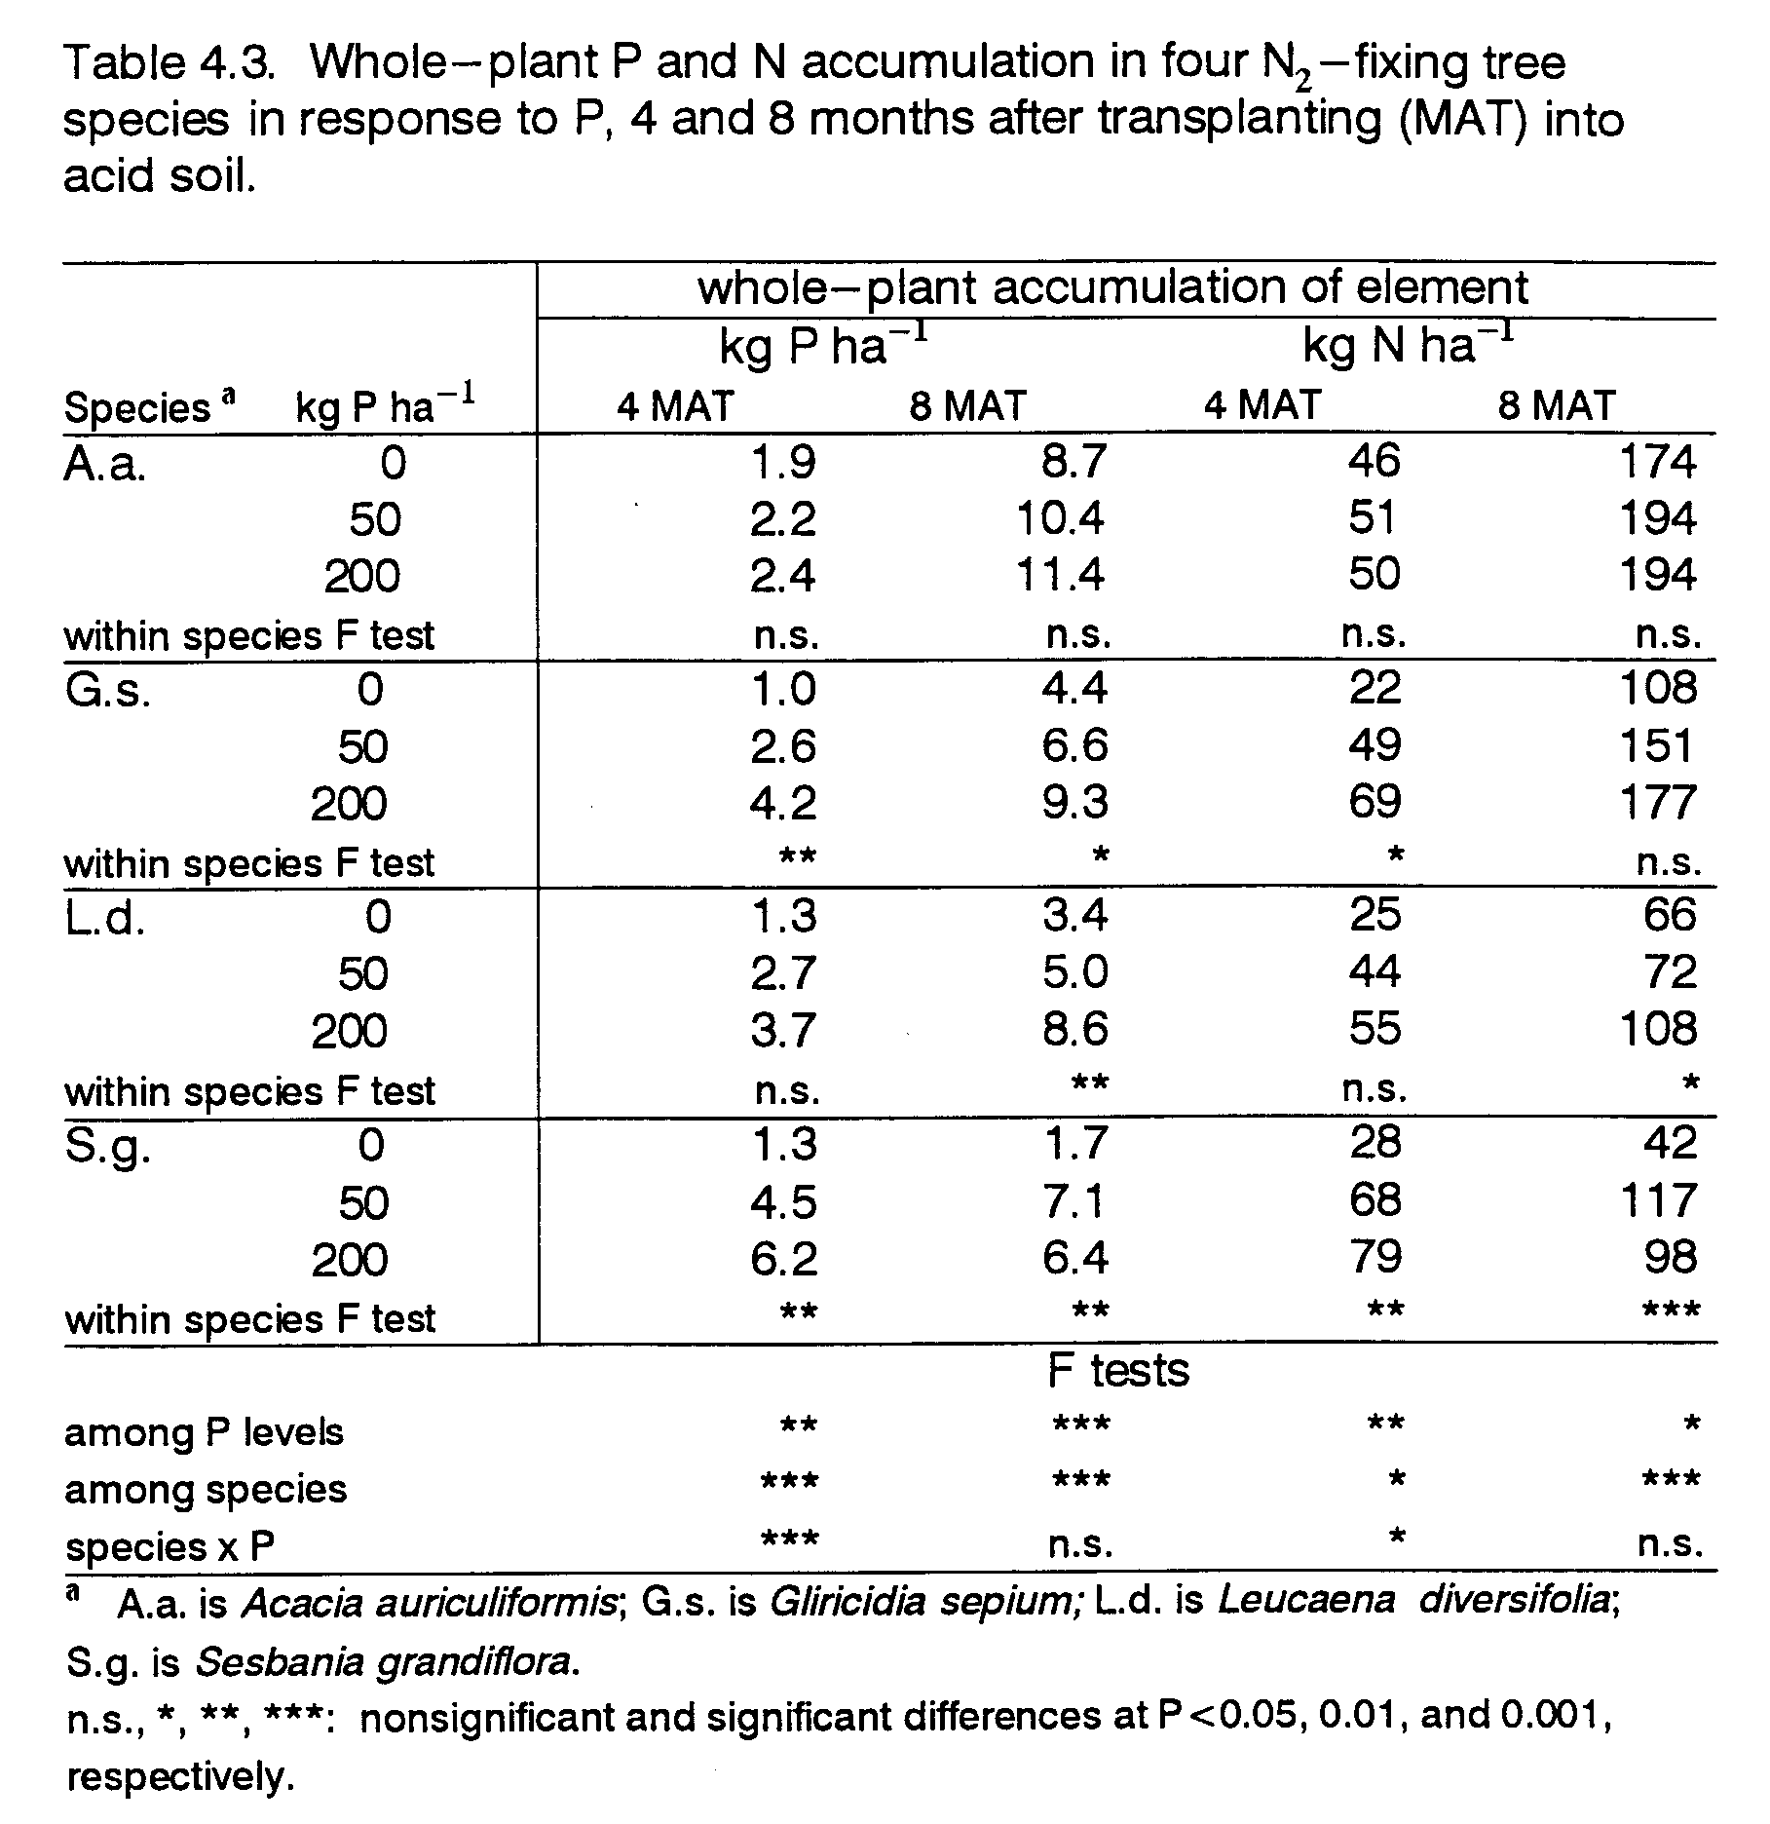
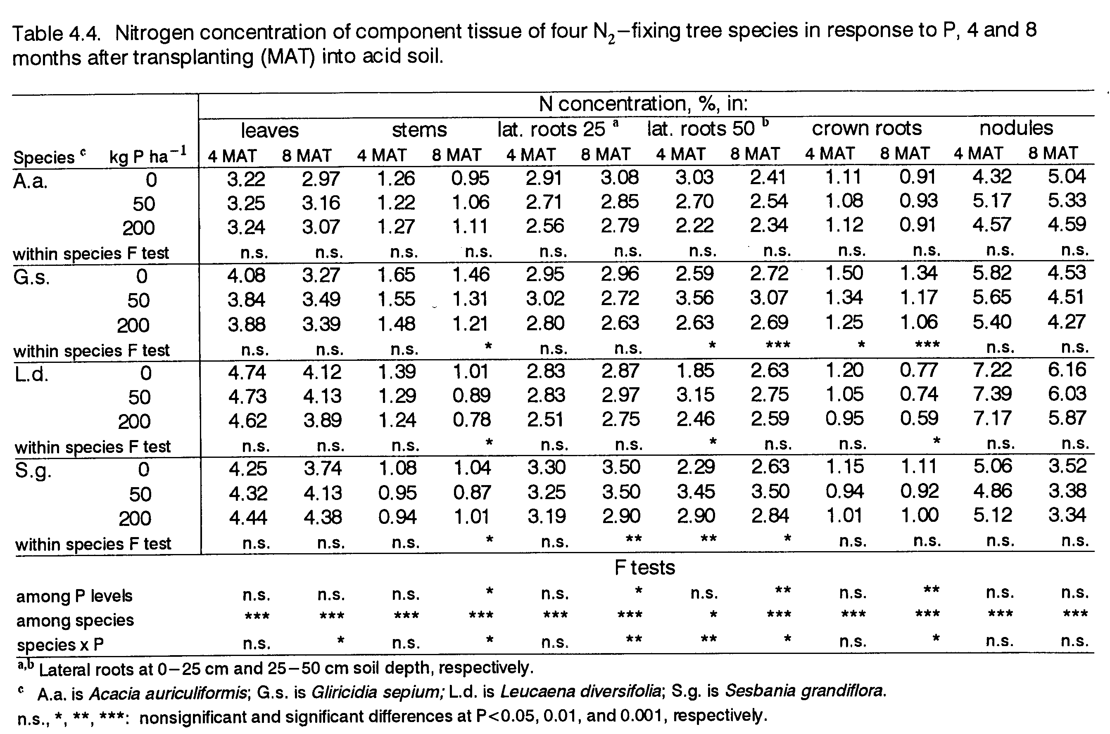
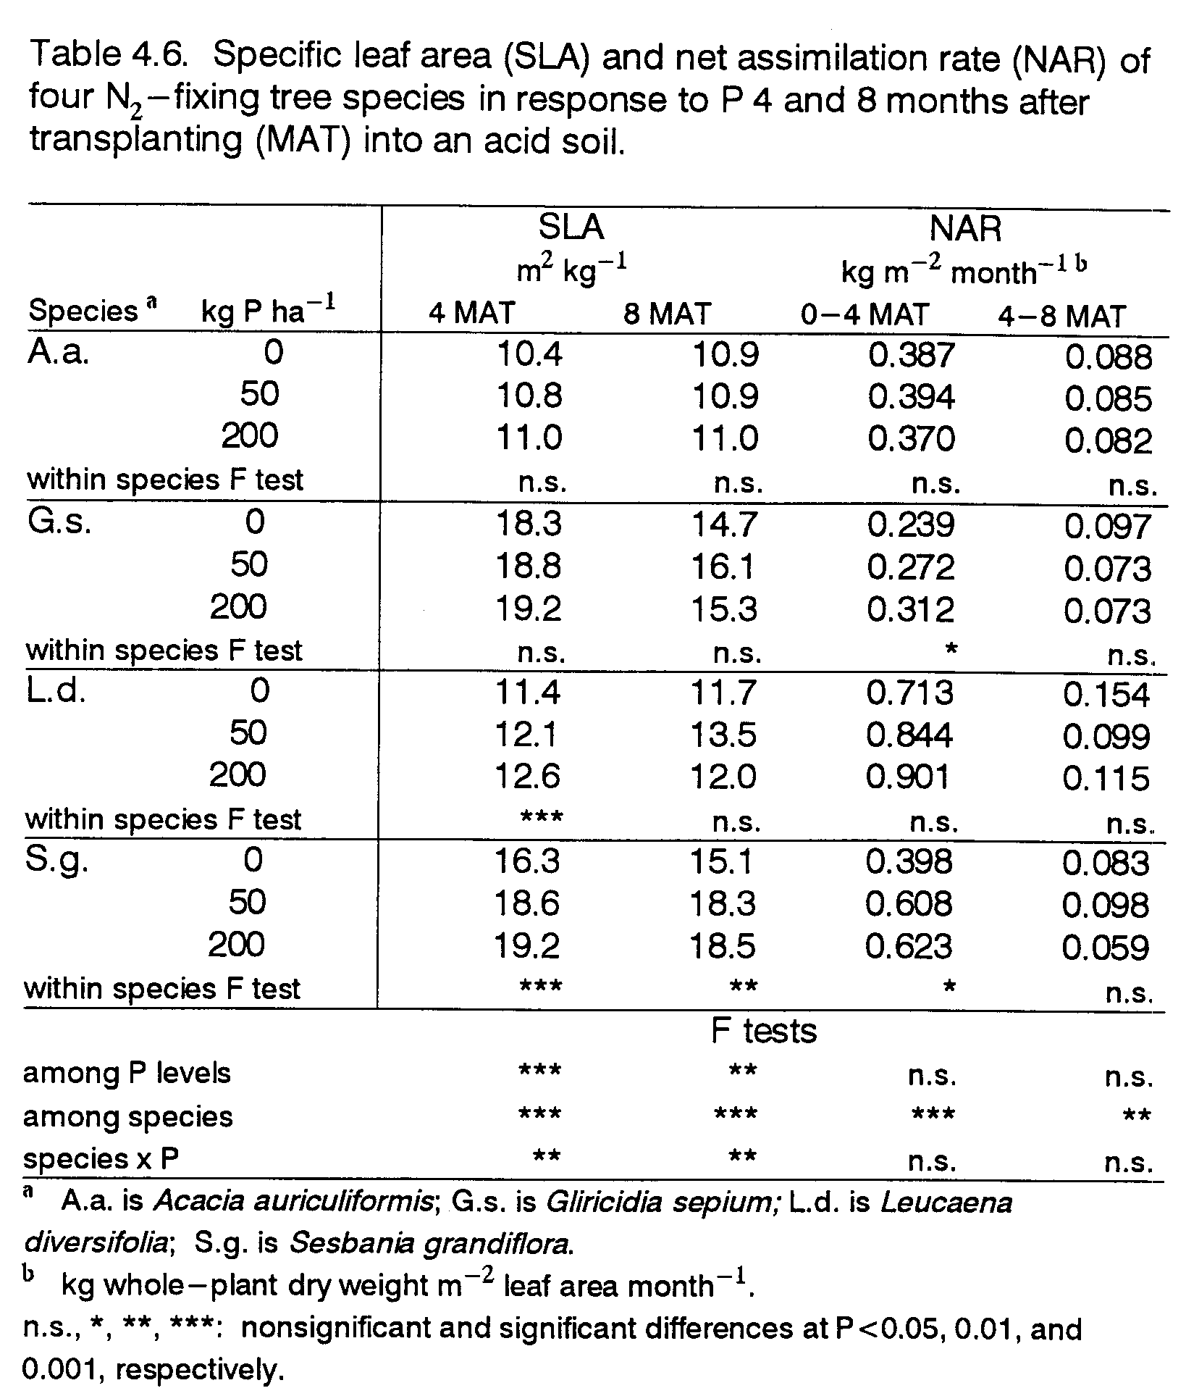
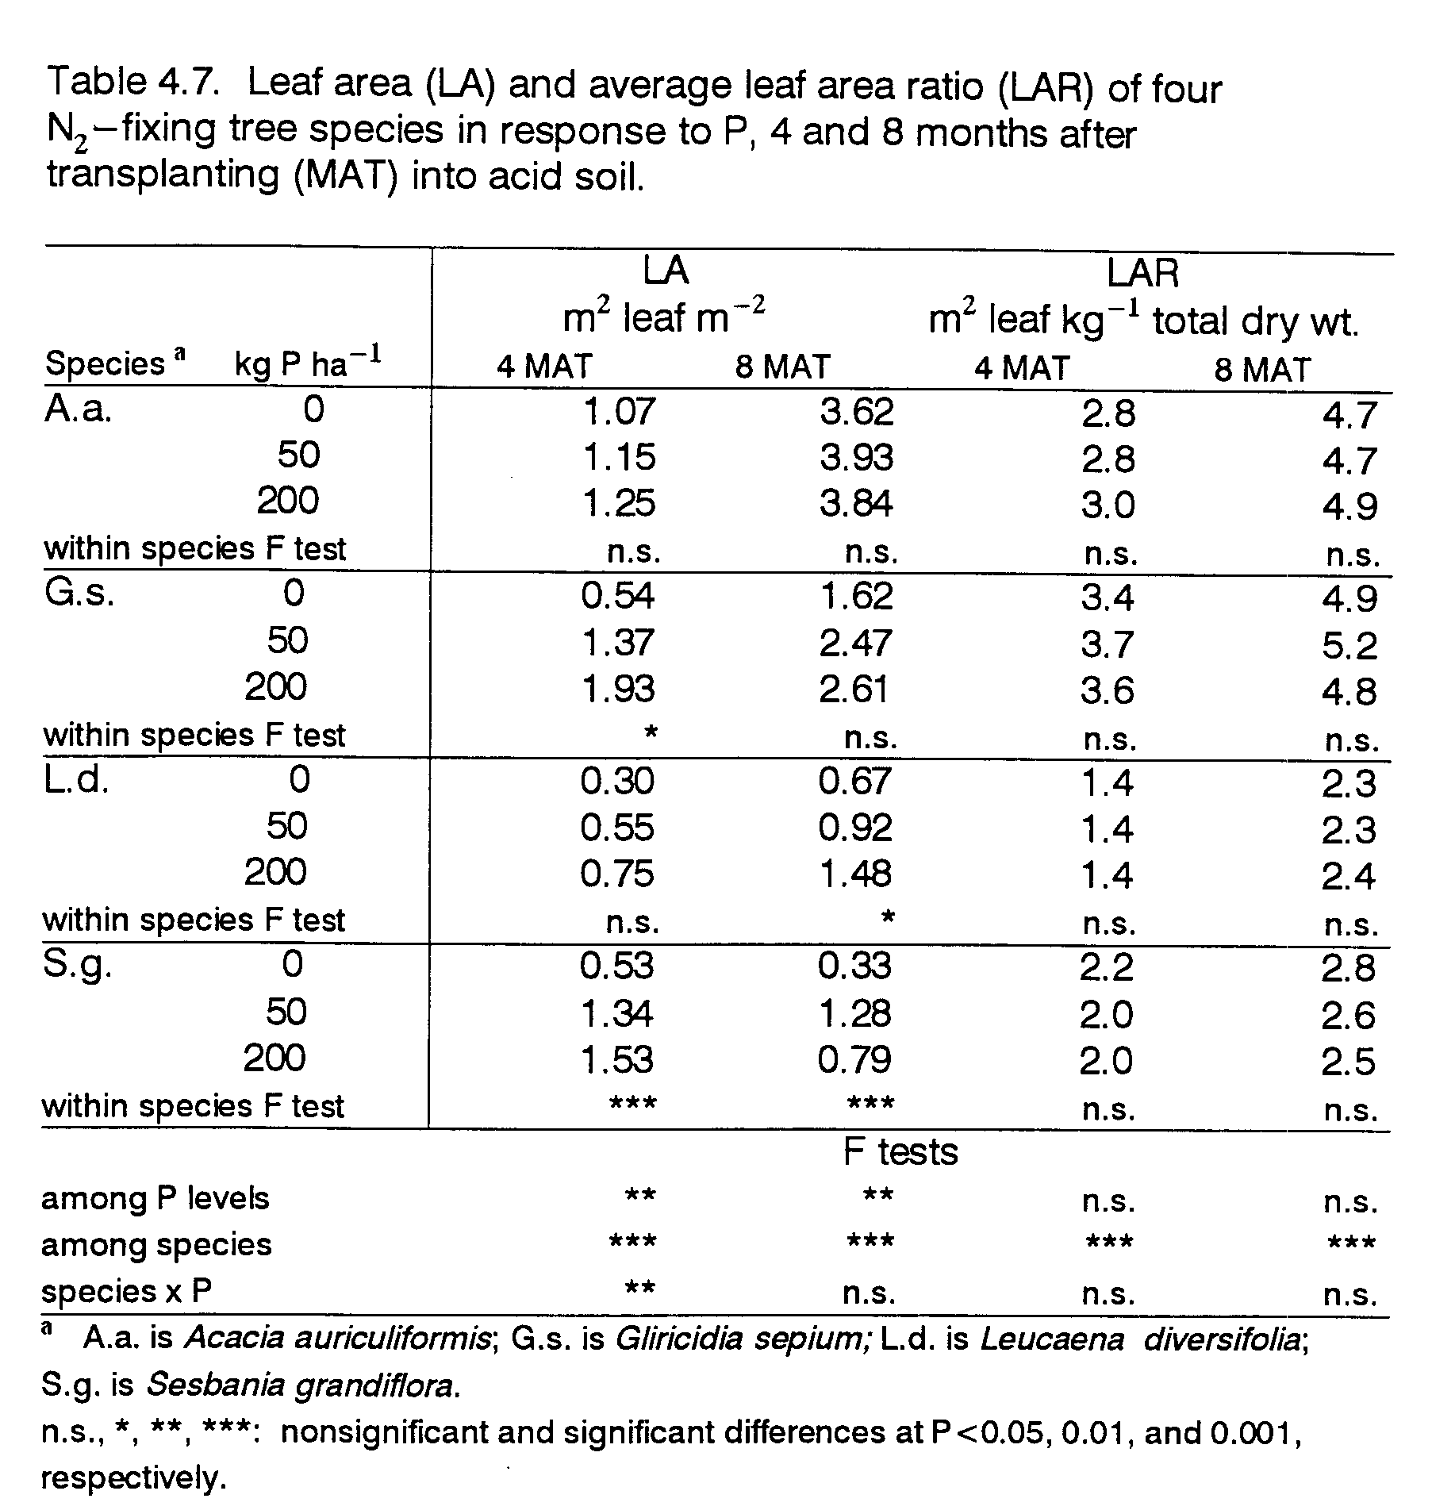
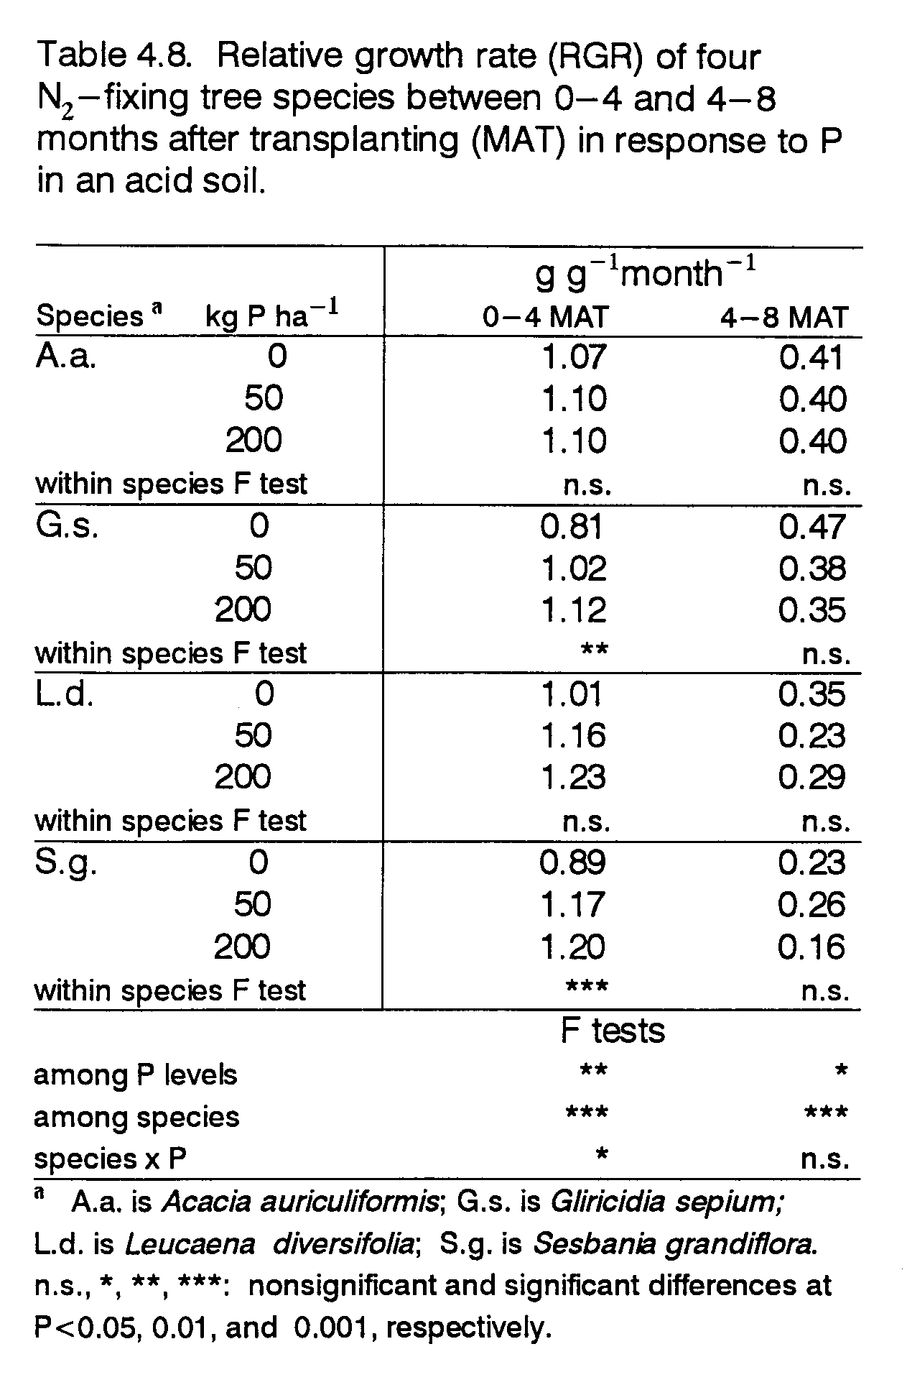
CHAPTER 5. Thesis Conclusion

The performance of five NFT species in response to P treatments revealed distinct growth habits that were associated with the degree of low-P tolerance in these species. Knowledge of the growth habits of these species in response to P fertilization permits their better utilization in P-limited agroforestry systems. This thesis generated information on growth strategies of NFT species in P-deficient soil, and in response to P fertilization, during establishment and early growth.
Of the NFT species included in this thesis research, two Acacia species, A.m. and A.a., demonstrated the greatest degree of tolerance to low P availability. The apparent low-P tolerance of these species was associated with low internal P demand for whole-plant growth and BNF. Though in pots these species displayed greater P uptake efficiency, in the field, the efficiencies of root (and leaf) function of A.a. were no higher than in the responsive species.
Initial growth of the Acacia species was slow, but by 8 MAT, A.a. trees were the largest of all species in the field on acid soil with very low levels of extractable P, A.a. was capable of high biomass production, with a roughly equal distribution of biomass between leaves and stems, and with relatively low investment of biomass, P, and N to below-ground components (particularly to crown roots). Leaf biomass production was highest in A.a. And, despite having the lowest leaf P concentrations, A.a. allocated a greater fraction of plant P and N to leaves and had greater total amounts of P and N in leaf biomass than any other species.
Studies on leaf litter formation and decomposition were not conducted, but A.a. leaves appeared to be longer-lived on the tree, which may be part of a strategy for nutrient conservation in A.a. Also, A.a. leaves, which were thicker and waxier than leaves of the other species, appeared to decompose more slowly as litter. These characteristics of A.a. leaf production and composition delimit the potential uses of this species. Acacia auriculiformis may better fulfill needs for high biomass production and long-lasting ground cover, such as in systems of land rehabilitation and wood production, than needs for leaves with high P concentration, rapid break-down, or digestibility, such as in systems requiring green manure or animal feed.
Of the species which required P fertilization for better growth, S.g. performed the most poorly at 0 P, but also had the lowest external P demand for achieving its acid-soil growth potential. With an application of only 50 kg P ha⁻¹, S.g. was the fastest species to become established in the field, producing more biomass than any other species by 4 MAT. While this species was capable of fast growth with low P application, its leaf production was very low. A greater fraction of biomass and P went to stem tissue in S.g. than in the other species. This species may be a good choice for systems requiring rapid wood production in which moderate P fertilization is feasible.
Leucaena diversifolia was similar to S.g. with respect to biomass partitioning. Biomass and P partitioning was relatively low to leaves and high to stems, suggesting that L.d. is also well-suited to meet needs for wood products. However, despite low production of leaf biomass in both L.d. and S.g., the N and P concentrations of leaves were the highest in these species. Therefore, L.d. and S.g. may fulfill needs for small amounts of high-quality fodder or green manure. Selection between these two species would partly depend on the level of soil P fertility since L.d. displayed a higher external P demand than did S.g.
Gliricidia sepium appeared to have the greatest growth potential of all the species. In pots it outperformed all other species at both low and high P levels. In the field, it had a slower start and by 8 MAT was the largest producer of biomass, though only at the highest P level. The discrepancy between pot and field results for this species was associated with different levels of PUE. Internal P concentrations were lower in potted G.s. than in field-grown G.s. These differences in PUE may be attributable to the fact that different provenances were used in the pot and field experiments.
However, there were also similarities between the two G.s. provenances. In both studies, G.s. appeared capable of even greater growth with additional P fertilization. High external P demand of both G.s. provenances was associated with their having the largest fraction of biomass and P allocated to roots, and the lowest efficiency of P uptake per unit of root. Gliricidia sepium roots had the most extensive proliferation in the soil and the highest RSA per unit of plant dry weight. Implications are that with greater P fertility, increased growth of G.s. could result in a considerably extensive root system. Such a trait in G.s. suggests that it could be more competitive with companion crops, over a larger area of soil, for water and nutrients, particularly in a fertilized system.
The role of BNF in mediating P-response of the trees demonstrates the importance of identifying effective rhizobia for NFT species grown in N- and P-limited systems. In the study soil N was the most limiting nutrient, as is the case in many agricultural soils world-wide. Therefore, an effective BNF symbiosis in P-deficient, acid soil is necessary for the expression of low-P tolerance by NFT species. The tolerance of the Acacia species was associated with their having a BNF symbiosis also tolerant of low P fertility. Fortunately, effective rhizobia for these species were known, and in using them the inherent low-P tolerance of the species could be demonstrated.
By the same token, improved knowledge of effective VAM symbioses is also critical to correctly assessing the low-P tolerance of NFT species. Trees which are dependent on symbiosis with particular VAM species to express low-P tolerance may be inaccurately evaluated in the absence of those VAM species. Information on appropriate VAM inoculant for the different species does not exist. To avoid inadvertent preferential treatment of a species in these experiments, trees were not inoculated with VAM. However, all species were infected by native soil VAM. It is unlikely that variable effectiveness of native soil VAM among the NFT species confounded the P variable of the pot and field experiments. Similar P response trends were obtained in pot and field experiments despite differences in relative VAM infection rates between the two experiments.
Focus on establishment and early growth is important since the long-term success of any system first depends on successful establishment. However, there are dangers in selecting species based solely on early-growth performance, particularly relevant to perennial species. Growth strategies for successful establishment (such as fast growth) can be quite different from strategies for long-term survival of low P fertility (such as slow growth). Longerterm growth assessments of low-P tolerance are also needed since trees typically remain in agroforestry systems for numerous years.
LITERATURE CITED

Aboulroos, S.A. and N.E. Nielson. 1979. Mean rate of nutrient uptake per unit of root and the fineness, length and density of barley roots in soil at various phosphorus levels. Acta Agric. Scand., 29:326-330.

Aerts, R. 1990. Nutrient use efficiency in evergreen and deciduous species from heathlands. Oecologia, 84:391-397.

Ahlawat, I.P.S. and C.S. Saraf. 1983. Growth analysis in pigeon pea Cajanus cajan (L.) Huth under differing management conditions. Indian J. Agron., 28(3):263-269.

Asher, C.J. and J.F. Loneragan. 1967. Response of plants to phosphate concentration in solution culture. I. Growth and phosphorus content. Soil Sci., 103:225-233.

Barber, S.A. 1984. Soil Nutrient Bioavailability. A Mechanistic Approach. Wiley, New York.

Barley, K.P. 1970. The configuration of the root system in relation to nutrient uptake. Adv. Agron., 22:159-201.

Benge, M.D. 1990. Little-known acacias -- promising trees for agroforestry. Agroforestry Today, 1(4):14-15.

Blair, G.J. and D.C. Godwin. 1991. Phosphorus efficiency in pasture species. VII. Relationships between yield and P uptake and root parameters in two accessions of white clover. Aust. J. Agric. Res., 42:1271-1283.

Blair, G.J. and E.J. Wilson. 1990. Phosphorus efficiency in pasture species. IV. Yield, efficiency parameters and partitioning of P in two white clover accessions under varying levels of P supply in solution culture. Aust. J. Agric. Res., 41:1071-1082.

Bongarten, B.C. and R.O. Teskey. 1987. Dry weight partitioning and its relationship to productivity in loblolly pine seedlings from seven sources. For. Sci., 33(2):255-267.

Bray, R.A. and C.T. Sorensson. 1992. Leucaena diversifolia: Fast-growing Highland NFT Species. NFT Highlights, 92-05. NFTA, USA.

Breeze, V.G., A. Wild, M.J. Hopper, and L.H.P. Jones. 1984. The uptake of phosphate by plants from flowing nutrient solution. II. Growth of Lolium perenne L. at constant phosphate concentrations. J. Exp. Bot., 35:1210-1221.

Caradus, J.R. 1981. Effect of root hair length on white clover growth over a range of soil phosphorus levels. N.Z. J. Agri. Res., 24:353-358.

Cassman, K.G., A.S. Whitney, and K.R. Stockinger. 1980. Root growth and dry matter distribution of soybean as affected by phosphorus stress, nodulation, and nitrogen source. Crop Sci., 20:239-244.

Cassman, K.G., A.S. Whitney, and R.L. Fox. 1981. Phosphorus requirements of soybean and cowpea as affected by mode of N nutrition. Agron. J., 73:17-22.
Chadhokar, P.A. 1982. Gliricidia maculata: A promising legume fodder plant. World Animal Review, 44:36-43.

Chapin, F.S. III. 1980. The mineral nutrition of wild plants. Ann. Rev. Ecol. Syst., 11:233-260.

Cooperband, L.R., R.E.J. Boerner, and T.J. Logan. 1994. Humid tropical leguminous tree and pasture grass responsiveness to vesicular-arbuscular mycorrhizal infection. Mycorrhiza, 4:233-239.

Crawford, D.T., B.G. Lockaby, and G.L. Somers. 1991. Genotype-nutrition interactions in field-planted loblolly pine. Can. J. For. Res., 21:1523-1532.

Dela Cruz, R.E., M.Q. Manalo, N.S. Aggangan, and J.D. Tambalo. 1988. Growth of three legume trees inoculated with VA mycorrhizal fungi and rhizobium. Plant Soil, 108:111-115.

Dommergues, Y.R. 1987. The role of biological nitrogen fixation in agroforestry. In: Agroforestry: A Decade of Development, H.A. Steppler and P.K.R. Nair (eds.), pp. 245271. ICRAF, Nairobi, Kenya.

Dorich, R.A. and D.W. Nelson. 1983. Direct colorimetric measurement of ammonium in potassium chloride extracts of soils. Soil Sci. Soc. Am. J., 47:833-836.

Fredeen, A.L., I.M. Rao, and N. Terry. 1989. Influence of phosphorus nutrition on growth and carbon partitioning in Glycine max. Plant Physiol., 89:225-230.

Garcia, M. and J. Ascencio. 1992. Root morphology and acid phosphatase activity in tomato plants during development of and recovery from phosphorus stress. J. Plant Nutr., 15:2491-2503.

Gates, C.T. 1974. Nodule and plant development in Sylosanthes humilis. H.B.K.: Symbiotic response to phosphorus and sulphur. Aust. J. Bot., 22:45-55.

Gerloff, G.C. 1977. Plant efficiencies in the use of N, P and K. In: Plant Adaptation to Mineral Stress in Problem Soils, M.J. Wright (ed.), pp. 161-174. Cornell University Press, New York.

Giovannetti, M. and B. Mosse. 1980. An evaluation of techniques for measuring vesicular arbuscular mycorrhizal infection in roots. New Phytol., 84:489-500.

Gray, J.T. and W.H. Schlesinger. 1983. Nutrient-use by evergreen and deciduous shrubs in southern California. J. Ecol., 71:43-56.

Gutschick, V.P. 1993. Nutrient-limited growth rates: roles of nutrient-use efficiency and of adaptations to increase uptake rate. J. Exp. Bot., 44:41-51.

Habte, M. and D. Turk. 1991. Response of two species of Cassia and Gliricidia sepium to vesicular-arbuscular mycorrhizal infection. Commun. Soil Sci. Plant Anal., 22 (17-18):1861-1872.
Hallmark, W.B. and S.A. Barber. 1984. Root growth and morphology, nutrient uptake, and nutrient status of early growth of soybeans as affected by soil P and K. Agron. J., 76:209-212.

Haynes, B., R.T. Koide, and G. Elliott. 1991. Phosphorus uptake and utilization in wild and cultivated oats (Avena spp.). J. Plant Nutr., 14(10):1105-1118.

Huang, R.S., W.K. Smith, and R.S. Yost. 1985. Influence of vesicular-arbuscular mycorrhiza on growth, water relations, and leaf orientation in Leucaena leucocephala (Lam.) de Wit. New Phytol., 99:229-243.

Hunt, R. 1978. Plant Growth Analysis. The Institute of Biology’s Studies in Biology No.96, Edward Arnold Limited, London.

Israel, D.W. 1987. Investigation of the role of phosphorus in symbiotic dinitrogen fixation. Plant Physiol., 84:835840.

Israel, D.W. and T.W. Rufty, Jr. 1988. Influence of phosphorus nutrition on phosphorus and nitrogen utilization efficiencies and associated physiological responses in soybean. Crop Sci., 28:954-960.

Kemp, P.D. and G.J. Blair. 1991. Phosphorus efficiency in pasture species. VI. A comparison of Italian ryegrass, phalaris, red clover and white clover over time. Aust. J. Agric. Res., 42:541-558.

Kirschbaum, M.U.F., D.W. Bellingham, and R.N. Cromer. 1992. Growth analysis of the effect of phosphorus nutrition on seedings of Eucalyptus grandis. Aust. J. Plant Physiol., 19:55-66.

Koske, R.E. and J.N. Gemma. 1989. A modified procedure for staining roots to detect VA Mycorrhizae. Mycol. Res., 92:486-505.

Krannitz, P.G., L.W. Aarsen, and D.D. Lefebvre. 1991. Correction for non-linear relationships between root size and short term Pi uptake in genotype comparisons. Plant Soil, 133:157-167.

Manjunath, A. and M. Habte. 1989. Rate variables associated with P uptake, utilization and growth of mycorrhizal and nonmycorrhizal Leucaena leucocephala. J. Plant Nutr., 12(6):755-768.

Manjunath, A. and M. Habte. 1991. Root morphological characteristics of host species having distinct mycorrhizal dependency. Can. J. Bot., 69:671-676.

Menge, J.A., C.K. Labanauskas, E.L.V. Johnson, and R.G. Platt. Partial substitution of mycorrhizal fungi for phosphorus fertilization in the greenhouse culture of citrus. Soil Sci. Soc. Am. J., 42:926-930.

Miller, G.L. and E.E. Miller. 1948. Determination of nitrogen in biological materials. Anal. Chem., 20:481-488.

Mosse, B. 1981. Vesicular-arbuscular mycorrhiza research for tropical agriculture. Research Bulletin 194, Hawaii Institute of Tropical Agriculture and Human Resources.

Mulligan, D.R. and J.W. Patrick. 1985. Growth and phosphorus partitioning in Eucalyptus pilularis Smith seedlings raised in a phosphorus-deficient soil. Aust. J. Bot., 33:245-59.

Mulligan, D.R. and J.W. Patrick. 1985b. Phosphorus and carbon economies of ectomycorrhizal seedlings of Eucalyptus pilularis Smith. Aust. J. Plant Physiol., 12:669-679.

Mulligan, D.R. and R. Sands. 1988. Dry matter, phosphorus and nitrogen partitioning in three Eucalyptus species grown under a nutrient deficit. New Phytol., 109(1):21-28.

Ndoye, I., K. Tomekpe, B. Dreyfus, and Y.R. Dommergues. 1990. Sesbania and Rhizobium symbiosis: nodulation and nitrogen fixation. In: Perennial Sesbania Species in Agroforestry Systems, B. Macklin and D.O. Evans (eds.), pp. 31-38. NFTA, Waimanalo, Hawaii.

Nelson, W.L., A. Mehlich, and E. Winters. 1953. The development, evaluation, and use of soil tests for phosphorus availability. Agronomy, 4:153-188.

NFTA. 1990. Perennial Sesbania Production and Use. D.O. Evans and B. Macklin, eds.

Nye, P.H. and P.B. Tinker. 1977. Solute Movement in the Soil-Root System. Blackwell Scientific Publications, Oxford.

Palm, C.A., A.J. McKerrow, K.M. Glasener, and L.T. Szott. 1991. Agroforestry systems in lowland tropics: Is phosphorus important? In: Phosphorus Cycles in Terrestrial and Aquatic Ecosystems in South and Central America, H. Tiessen, D. Lopes-Hernandez, and I.H. Salcedo (eds.), pp. 134-141. Saskatchewan, Institute of Pedology, Saskatoon.

Paynter, B.H. 1993. Effect of external phosphorus and seed phosphorus supply on the shoot and root growth of yellow serradella, burr medic, and subterranean clover. J. Plant Nutr., 16(11):2313-2331.

Peoples, M.B., A.W. Faizah, B. Rerkasem, and D.F. Herridge. 1989. Methods for evaluating nitrogen fixation by nodulated legumes in the field. ACIAR Monograph No. 11, Canberra, A.C.T.

Pongsakul, P. and E.S. Jensen. 1991. Dinitrogen fixation and soil N uptake by soybeans as affected by phosphorus availability. J. Plant Nutr., 14(8):809-823.

Poorter, H. 1989. Interspecific variation in relative growth rate: On ecological causes and physiological consequences. In: Causes and Consequences of Variation in Growth Rate and Productivity of Higher Plants, Lambers H. et al. (eds.), pp 45-68. SPB Academic Publishing, The Hague.

Reddell, P., P.A. Rosbrook, G.D. Bowen, and D. Gwaze. 1988. Growth response on Casuarina cunninghamiana plantings to inoculation with Frankia. Plant Soil, 108:79-86.

Robson, A.D. 1983. Mineral nutrition. In: Nitrogen Fixation of Legumes, W.J. Broughton (ed.), pp. 37-55. Clarendon Press, Oxford.
Sanchez, P.A. and T.J. Logan. 1992. Myths and science about the chemistry and fertility of soils in the tropics. In: Myths and Science of Soils of The Tropics, SSSA Special Publication No. 29, pp. 35-46. Madison, WI.

Sanchez, P.A. and G. Uehara. 1980. Management considerations for acid soils with high phosphorus fixation capacity. In: The Role of Phosphorus in Agriculture, F.E. Khasawneh, E.C. Sample, and E.J. Kamprath (eds.), pp. 471509. ASA, CSSA, and SSSA, Madison, WI.

Sanginga, N., G.D. Bowen, and S.K.A. Danso. 1991. Intra-specific variation in growth and P accumulation of Leucaena leucocephala and Gliricidia sepium as influenced by soil phosphate status. Plant Soil, 133:201-208.

Sanginga, N. 1992. Early growth and N₂-fixation of Leucaena and Gliricidia at different levels of phosphorus application. Fert. Res., 31:165-173.

Sanginga, N., S.K.A. Danso, F. Zapata, and G.D. Bowen. 1994. Field validation of intraspecific variation in phosphorus use efficiency and nitrogen fixation by provenances of Gliricidia sepium grown in low P soils. Appl. Soil Ecol., 1:127-138.

SAS Institute. 1985. SAS User’s Guide: Statistics. SAS Institute Inc., Cary, North Carolina.

Sawada, S., T. Igarashi, and S. Miyachi. 1983. Effects of phosphate nutrition on photosynthesis, starch and total phosphorus levels in single rooted leaf or dwarf bean. Photosynthetica, 17(4):484-490.

Schenk, M.K. and S.A. Barber. 1979. Root characteristics of corn genotypes as related to P uptake. Agron. J., 71:921-924.

Shepherd, K.D. 1991. Phosphorus in agroforestry systems: New research initiatives of the International Council for Research in Agroforestry. International Workshop on Phosphorus Cycles in Terrestrial and Aquatic Ecosystems in Africa, Nairobi, Kenya.

Siaw, D.E.K.A., B.T. Kang, and D.U.U. Okali. 1991. Alley cropping with Leucaena leucocephala (Lam.) De Wit and Acioa barteri (Hook. f.) Engl. Agrofor. Syst., 14:219-231.

Singer, M.J. and D.N. Munns. 1987. Soils: An Introduction. Macmillan Publishing Co., NY.

Singleton, P.W. 1983. A split-root growth system for evaluating the effect of salinity on components of the soybean/Rhizobium japonicum symbiosis. Crop Sci., 23:259262.

Smucker, A.J.M., S.L. McBurney, and A.K. Srivastava. 1982. Quantitative separation of roots from compacted soil profiles by the hydropneumatic elutriation system. Agron. J., 74:500-503.

Somasegaran, P. and H.J. Hoben. 1994. Handbook for Rhizobia: Methods in Legume-Rhizobium Technology. Springer-Verlag New York, Inc.

Szott, L.T., C.A. Palm, and P.A. Sanchez. 1991. Agroforestry in acid soils of the humid tropics. Adv. Agron., 45:275-301.

Taylor, B.K. and F.H. Goubran. 1976. Effects of phosphate and pH stress on the growth and function of apple roots. Plant Soil, 44:149-162.

Tennant, D. 1975. A test of a modified line intersect method of estimating root length. J. Ecol., 63:995-1001.

Turk, R.D. 1991. The response of tree legumes to inoculation with rhizobia in relation to their rhizobial specificity and the density of indigenous rhizobia. MSc Thesis, Dept. of Agronomy and Soil Science, University of Hawaii.

Turnbull, J. 1987a. Acacia auriculiformis: The Adaptable Tropical Wattle. NFT Highlights, 87-03. NFTA, USA.

Turnbull, J. 1987b. Acacia mangium: A Fast-growing Tree for the Humid Tropics. NFT Highlights, 87-04. NFTA, USA.

van Kessel, C., P.W. Singleton, and H.J. Hoben. 1985. Enhanced N-transfer from a soybean to maize by vesicular-arbuscular mycorrhizal (VAM) fungi. Plant Physiol., 79:562563.

Vincent, J.M. 1970. A Manual for The Practical Study of Root-Nodule Bacteria. IBP Handbook No. 15. Burgess and son (Abingdon) LTD, Berkshire.

Watanabe, F.S. and S.R. Olsen. 1965. Test of an ascorbic acid method for determining phophorus in water and NaHCO₃ extracts from soil. Soil Sci. Soc. Am. J., 29:677-678.

Yost, R.S. and R.L. Fox. 1979. Contribution of mycorrhizae to P nutrition of crops growing on an oxisol. Agron. J., 71:903-908

